Greetings to Stainton and Hemlington Church Members and Friends of Stainton Church

Welcome to the Stainton Church e-News for

Friday 19th September 2025

We hope you are well and keeping safe. If you need any
practical support, please do get in touch.


Picture credit: Daniel Davies

This September we are celebrating our “Coffee and Kids” Toddler Group’s 10th Anniversary with a Party for the (grand)parents and children who have enjoyed time with us (mostly) on Wednesday mornings over the past ten years. The Party will be in the Church and Parish Room from 2.00-4.30pm on Saturday 20th September 2025. At the time of writing, we have 32 adults and 27 children signed up to attend. We shall also be welcoming the Team from BiGKIDs, the Middlesbrough-based children’s charity, who will leading the children in lots of fun – perhaps the adults too!

_____________________________________

Come and meet Bishop Barry for Coffee
On Tuesday 23rd September 2025 at 10am – 12.30pm there is a Deanery Coffee morning with Bishop Barry for Lay officers and volunteers, at Stokesley Parish Church. This invitation is extended to anyone who has an active role in their Church, so this invitation is being circulated as widely as possible. This is NOT a meeting just for PCC Members but is open to anyone with an interest on what goes on in the Church. [Editor’s note: I have booked to attend this meeting. If anyone would like to attend and would like a lift, please let me know by e-mail or by SMS text msg (07910-075752).

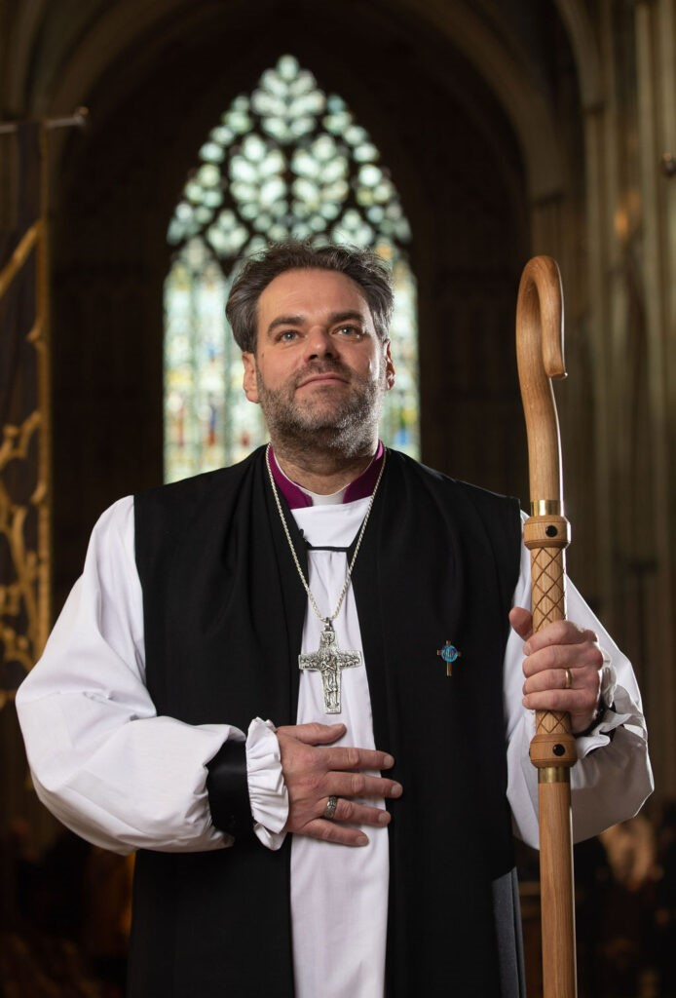

This gathering provides a wonderful opportunity to meet Bishop Barry and acknowledge the invaluable contributions of lay people who take on roles and responsibilities and are the backbone of our church and discipleship.

This informal event could cover various topics, including different forms of discipleship, outreach activities and the critical 'Back Office' work that supports our ministry, ensuring it remains solvent, legal, and operational. Bishop Barry will offer a Diocesan perspective on the current situation, changes, challenges and opportunities.

For anyone wishing to attend, please send an email to jgdickinson@outlook.com. Please include any particular questions or points you would like to ask the Bishop, or have included in the discussion.
Best wishes, John Dickinson, Stokesley Deanery Lay Dean. Tel: 079 900 10368
_____________________________________
Plurality Bible Study Course


Picture Credit: The Bible Society
Our Vicar, Revd Laura Wild, is running a seven-week Bible Study Course for people from all three of our Churches. The Course is held at St Margaret's Church Hall, Brookfield at 2.00-3.00pm on the Mondays 8th September to 20th October 2025 and will follow "The Bible Series" material from the Bible Society.
The Bible Series will deepen our understanding of the Bible and its over-arching story and help us engage in great conversation. Discover the Bible: world-shaping literature, in one big story, which still cuts through to the heart today. The seven sessions are:
Part 1: Introducing the Bible – What is the Bible? See the Bible's relevance in the twenty-first century.
Part 2: Origins and Meaning – Why were we created? Genesis shows us that we are created on purpose, for a purpose.
Mon 22nd Sept - Part 3: Exodus and Freedom – What is freedom? Explore freedom from captivity and freedom in Jesus.
Part 4: Exile and Peace – How do we deal with suffering? Find hope beyond the darkness.
Part 5: Messiah and Love – Who is Jesus? Discover the source of true love.
Part 6: Spirit and Community – What part do we have to play? See how God uses normal people like us and how we are made for community.
Part 7: Hope and home – How does the story of the Bible end? Our future hope inspires confidence in our uncertainty today.
____________________________________
Services and Events in our Churches over the next two weeks
On Sunday 21st September 2025 – Trinity 14 – there will be services as follows:
At 9.30am at Brookfield Church an informal Breakfast Church service with discussion, quizzes and simple refreshments led by ur Vicar, Revd Laura Wild; in addition, part of the service will involve the Blessing of our Pets. [Editor's note: There will NOT be Holy Communion at this service]
At 9.30am at Hilton Church a service of Morning Praise led by Julia Ardley, our Authorised Lay Minister;
At 11.00am at Stainton Church a service of Holy Communion at which our Pioneer Minister, Revd Vanessa Kirby, will preside.
The lessons set in the Lectionary for Trinity 14 (Proper 20) are:
- Amos 8:4-7
- Psalm 113
- 1 Timothy 2:1-7
- Luke 16:1-13
There is a technical problem with the weekly Diocesan Reflections and the Reflections for Trinity 14 onwards are not yet available. The Reflections up to Trinity 12 are available at this link.
On Monday 22nd September 2025 at 2.00pm in Brookfield Church Hall there will be the third session (“Exodus and Freedom – What is freedom?”) of our Plurality Bible Study Course led by our Vicar, Revd Laura Wild. The sessions last for about one hour and follow “The Bible Series” material from The Bible Society.
On Tuesday 23rd September 2025 at 9.30am at Stainton Church there will be a half-hour Plurality Prayer Gathering.
On Wednesday 24th September 2025 at 10.00am at Brookfield Church there will be a service of Holy Communion.
_____________________________________

On Sunday 28th September 2025 – Trinity 15 there will be services as follows:
At 9.30am at Brookfield Church a service of Holy Communion at which our Vicar, Revd Laura Wild, will preside.
At 11.00am at Stainton Church a service of Holy Communion at which Revd Laura will also preside.
At 4.00pm at Hilton Church a Harvest Festival service led by Revd Laura.
The lessons set in the Lectionary for Trinity 15 (Proper 21) are:
- Amos 6:1a, 4-7
- Psalm 146
- 1 Timothy 6:6-19
- Luke 16:19-31
There is a technical problem with the weekly Diocesan Reflections and the Reflections for Trinity 14 onwards are not yet available. The Reflections up to Trinity 12 are available at this link.

On Monday 29th September 2025 at 2.00pm in Brookfield Church Hall there will be the fourth session (Exile and Peace – How do we deal with suffering?) of our Plurality Bible Study Course led by our Vicar, Revd Laura Wild. The sessions last for about one hour and follow “The Bible Series” material from The Bible Society.
On Tuesday 30th September 2025 at 9.30am at Stainton Church there will be a half-hour Plurality Prayer Gathering.
On Wednesday 1st October 2025 at 10.00am at Brookfield Church; there will be a service of Holy Communion at which our Vicar, Revd Laura Wild, will preside.
_____________________________________
Please continue to pray

… for Myanmar and neighbouring Thailand

Pray for all those affected by the recent massive earthquake that occurred in Myanmar on Friday 28th March 2025.

… for Afghanistan
Here is prayer from the United Nations website:
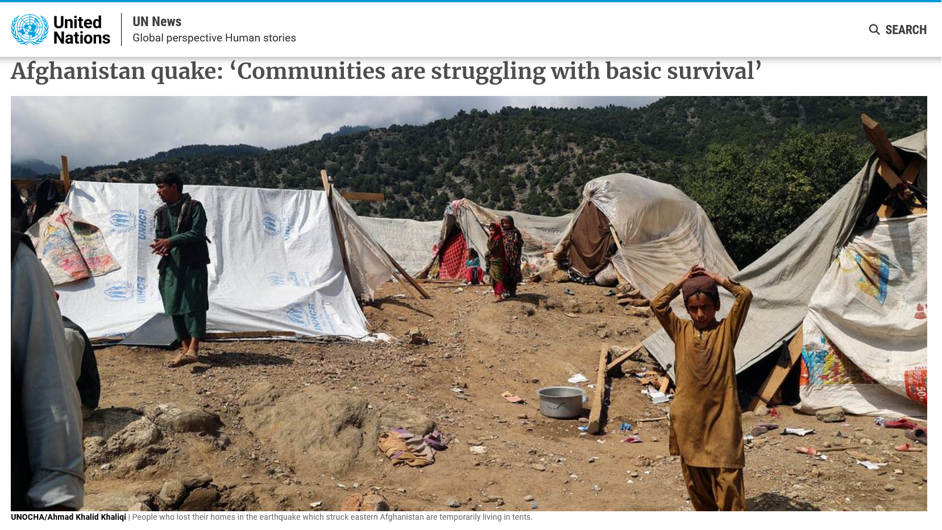
Following the recent multiple earthquakes on the 1st September 2025 here is a prayer from the Christian charity Tearfund:
Heavenly Father,
We come before you in this time of grief and loss in the aftermath of the deadly earthquakes in Afghanistan. We pray for the people affected by this disaster – those who are mourning loved ones, those who are recovering from injury, and those who are still waiting to be rescued.
As rescue efforts are made difficult by landslides and mountainous terrain, we ask that you clear the way for help to reach those who need it. Comfort those who mourn. Heal the injured. And provide shelter and essentials for the displaced.
Strengthen Tearfund’s staff and partners who are faithfully responding to the needs of survivors. Lay your loving hand over the areas affected. And bring peace, hope and restoration where there is devastation.
In Jesus’ name, Amen.

… for Israel, Palestine and now Iran

Here is a photo of Gaza taken from the BBC News website.

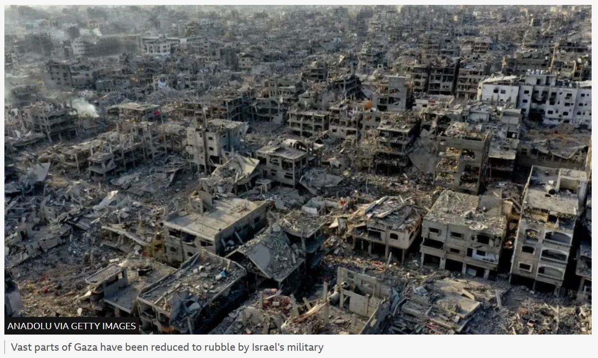

Here is a prayer from Ely Cathedral:
A Prayer for peace in Israel and Gaza
Heavenly Father, we pray for the many people whose lives have been torn apart by conflict in Gaza and Israel.
We pray especially those who have died, those who are grieving, the injured and those now without food, shelter or medical supplies. Strengthen and support the work of all relief organisations.
We pray also for those who have the power to bring peace. May they be touched by a spirit of compassion and kindness.
Lord hear us as we pray in the power of your Spirit, through Jesus Christ our Lord.
Amen

…. and for Ukraine and Russia

Here is a Litany of Lament by Bishop Eduard Khegay on the European Methodist Council website

Imagine a baby born in the Kiev metro and its exhausted mother sheltering from shells.
Christ weeps beside them.
Imagine a lonely grandmother and grandson in Luhansk, unable to sleep because of explosions and sirens.
Christ weeps beside them.
Imagine a Russian and a Ukrainian soldier looking at each other through the sights of a machine gun.
Christ weeps beside them.
Imagine the drivers standing in line for three nights at the Ukrainian-Polish border.
Christ weeps beside them.
Imagine friends on Facebook ready to destroy each other with their comments.
Christ weeps beside them.

Imagine the explosions near your home and the wounded in the east and west, in the south and north of Ukraine.
Christ weeps beside them.
Imagine hundreds of thousands of refugees from Ukraine in Europe and Russia.
Christ weeps beside them.
Imagine the coffins with 18-year-old boys just starting out in life, and their grief-stricken mothers.
Christ weeps beside them.
Imagine yourself embracing all these people.
Christ embraces them with you...
(by Bishop Eduard Khegay, UMC Eurasia), Source: https://www.facebook.com/bishop.eduard.khegay [Translated with www.DeepL.com/Translator]
_____________________________________

Please join us in praying for our Churches to Grow

Can we invite you to use our Revitalise "prayer for growth" in your personal quiet times with God?

Revitalise us Lord,
Enthuse in our congregations the desire for mission. Give
Vision to our planning and
Inspire our thoughts as we seek Your will.
Teach us to be more like You, Christ
Abiding in You and
Loving one another.
In growing healthy churches,
Sharing our faith, living Christ’s story
Every day, help us to be faithful disciples and bear much fruit. Amen.

_____________________________________

Pastoral Support - Here are the contact details for our Vicar, Revd Laura Wild:

Address: The Vicarage, 89 Low Lane, Brookfield, Middlesbrough TS5 9EF
Phone: 01642-598621
E-mail: rev.laura.wild@gmail.com

Laura's normal "day off" is Friday - if you need to contact her on that day, please leave a message on the answerphone.
______________________________________

Bob Ardley

26 Meldyke Lane, Stainton, Middlesbrough TS8 9AU T: 01642-284525 E: bob.ardley@ntlworld.com

