Greetings to Stainton and Hemlington Church Members and Friends of Stainton Church

Welcome to the Stainton Church e-News for

Friday 15th August 2025

We hope you are well and keeping safe. If you need any
practical support, please do get in touch.

Summer Family Activities at St Margaret’s Church, Brookfield

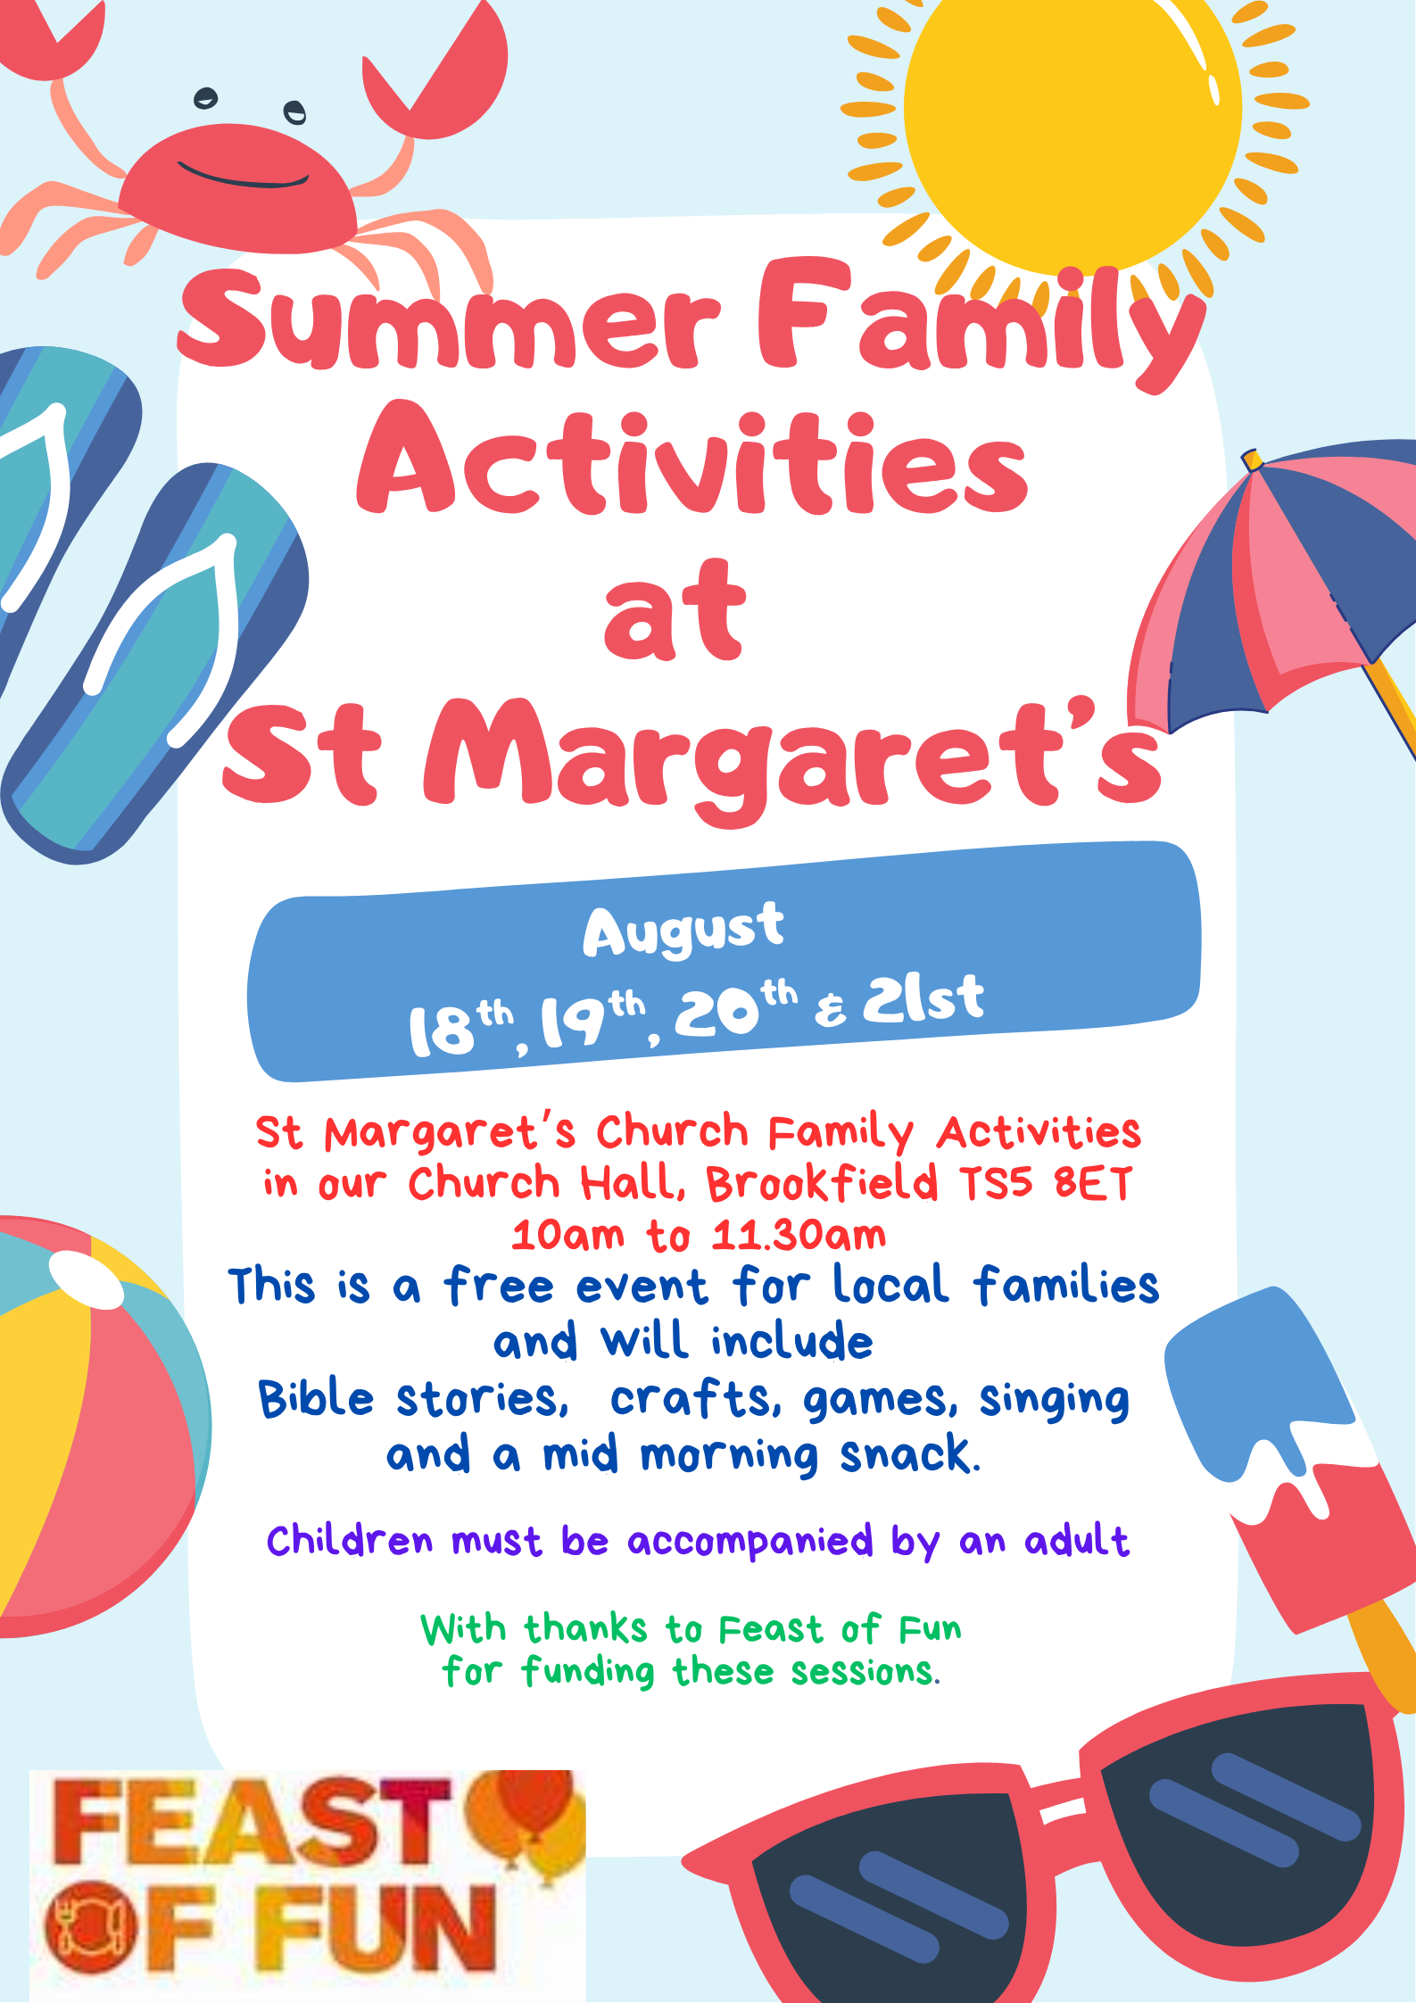

St Margaret's Church, Brookfield is hosting in the Church Hall some exciting Summer Family Activities on Mon 18th, Tues 19th, Wed 20th and Thurs 21st August from 10.00am to 11.30am. There will be Bible stories, crafts, games, singing and a mid-morning snack. Primary aged children and their parents, grandparents or carers are welcome; there will also be a toddler play area for little ones (pre-school children). All children will need to be accompanied by an adult.

Please contact Revd Vanessa by phone on 07804-234388 or e-mail on rev.vanessakirby@gmail.com for more details.
_____________________________________

Your Editor is pleased to tell you about “One for Israel”. It was established in 1990 and began as a Bible college and has since expanded to a multi-faceted ministry with the express goal of reaching Israelis with the Good News of Yeshua [Jesus], training and equipping the Body of Messiah in Israel, and blessing our community with Yeshua’s love.
The story and ministry of ONE FOR ISRAEL is part of something much larger – the miraculous restoration of the Jewish people and the miraculous unity between Jewish and Arab believers in Jesus.
We are seeing not only the physical restoration of Israel after a 2000-year exile, but a spiritual revolution is taking place right in front of our eyes. Jewish people are returning to their God and accepting the Messiah in numbers not seen since the early church! Not only that, but many Arab people are coming to the Lord and many Arab believers are finding a deep unity with their Jewish brothers and sisters.
ONE FOR ISRAEL exists to do ministry within this miracle.
We are Jews and Arabs, together serving Messiah Jesus, sharing the Gospel with Israel and the world, making disciples, training leaders, and blessing our communities in the name of Yeshua.
In a recent blog One for Israel spoke of the Double Meaning of Messianic Prophecy:

There is a lot of biblical prophecy that speaks about Yeshua. But I think it’s fair to say most people are blind to the double meaning in those passages. Many believers would cite Isaiah 53 as an obvious example of a biblical prophet speaking of the promised Messiah. We could also talk about the numerous other prophecies concerning His birth and early life, matters over which the man Jesus of Nazareth could have no control:
- The Messiah would be born in Bethlehem (Micah 5:2)
- He would be born of a virgin (Isaiah 7:14)
- He would be from the tribe of Judah (Genesis 49:10)
- He could come out of Egypt (Hosea 11:1)
- He would be called a Nazarene (Isaiah 11:1)
Then there are all the impossible miracles he would perform during His lifetime: He would heal lepers, open the eyes of the blind, and the lame would leap for joy as foretold in Isaiah 35:5-6. The religious leaders knew this to be true. They were looking for those signs. There are prophecies saying that the Messiah would be the Son of God (Psalm 2:12, Proverbs 30:4) and yet God Himself (Isaiah 9:6-7, Jeremiah 23:5-6, Zechariah 2:10). There is also a lot of prophecy about the way in which the Messiah would die; the timing and His manner of death, long before crucifixion was even invented, again, matters out of His control:
- He would be ‘cut off’ before the second temple was destroyed (Daniel 9:26)
- His hands and feet would be pierced (Psalm 22:17)
- He would be mocked and tortured before his execution (Isaiah 53:4-8)
- His friend would betray Him (Psalm 41:9)
- He would be offered vinegar on the cross (Psalm 69:21)
- None of His bones would be broken (Psalm 34:20)… and many more.

Why can’t Jewish people see?
You may be aware of these prophecies and many more like them. There are hundreds. We can look back with the confidence of hindsight and say, as improbable as they might have sounded at the time (a virgin giving birth? Really?), they came to pass exactly as described.
It’s easy for Christians to wonder why Jewish people don’t get it… why can they not see? Well. It’s in large part due to the fact that there is a double whammy going on in most of these prophecies. Christians often only see one side of the prophecy, and Jewish people tend to see the other.
If you look at Micah 5, Christians will see the birthplace of Yeshua, miraculously foretold with perfect accuracy. If a Jewish person looks at Micah 5, they see a heroic warrior coming to kick butt at the end of time. Take a look, but try to read it through the eyes of Israel. Go on—really, take a quick look—it’s here if you don’t have a Bible handy. Try and see what Jewish people see.
But most biblical prophecy works like this. Whether it’s Isaiah 61 (Good news to the poor AND the day of the Lord’s vengeance), Isaiah 9 (unto us a child is born AND God’s kingdom rule from Jerusalem, punishment of the wicked) or just about any prophecy you care to look at.
It’s time to start using two lenses. Christians need to start adjusting their vision to see the warrior Messiah in the very passages they know so well. Because it’s not like the Jewish Messianic expectation is wrong—it will indeed happen, just as it is written. And Jewish people need to start seeing that the first incarnation was there, in the midst of these passages, all along. And it’s not too late for them to receive Him as Messiah today, two thousand years later!
When we don’t see the double meaning
John the Baptist got it, but then again, did he? Here’s how he introduced his cousin, Jesus of Nazareth:
“I baptize you with water for repentance, but he who is coming after me is mightier than I, whose sandals I am not worthy to carry. He will baptize you with the Holy Spirit and fire. His winnowing fork is in his hand, and he will clear his threshing floor and gather his wheat into the barn, but the chaff he will burn with unquenchable fire.” (Matthew 3:11-12)
He knew Yeshua had come to baptize with the Holy Spirit and fire. He also warned of the unquenchable fire of God that was coming in judgement at the end of time. But perhaps he didn’t fully understand what he was seeing.
John saw both the first and second coming simultaneously, so when he was locked up in prison, on death row, the confusion about why the Messiah wasn’t busting him out of jail and blasting the evildoers must have been hard to take.
Now when John heard in prison about the deeds of the Christ, he sent word by his disciples and said to him, “Are you the one who is to come, or shall we look for another?” And Jesus answered them, “Go and tell John what you hear and see: the blind receive their sight and the lame walk, lepers are cleansed and the deaf hear, and the dead are raised up, and the poor have good news preached to them. And blessed is the one who is not offended by me.” (Matthew 11:2-6)
John the Baptist knew his cousin could rescue him, yet somehow He wouldn’t. He saw that this Jesus was truly the Messiah who would winnow, thresh, and burn, but reported the two comings in one breath. As is very common in Biblical prophecy. John didn’t seem to understand what he had seen. Why wasn’t Yeshua executing vengeance as the prophecy said? But John wasn’t wrong, was he? It was just an issue of timing. “Blessed is the one who is not offended by me”, says Yeshua. John had been so sure at first declaring, “Behold the Lamb of God who takes away the sins of the world!” But now he gets the disciples to go and check—did I get it wrong? The temptation to doubt and become disappointed with God, dismayed and offended must have been strong.
20:20 vision and the problem of unprepared people
It was hard for Jewish people in the time of Yeshua to accept that this humble carpenter from Nazareth who died the cruel, humiliating death of a criminal was their Messiah. But equally, many Christians are too settled and fixated on this first coming to see what Jewish people see. They are simply not mentally ready for the warrior from the tribe of Judah who will execute vengeance and punishment, which is exactly what Jewish people have been expecting.
The problem of an unprepared people is that they not only miss it when God acts according to His prophecies, but they may even oppose it.
The religious leaders of the day were not ready for what they saw, they were offended by the humble incarnation, so they rejected Yeshua and stood in opposition to God’s perfect plans. Lord, let it never be said of us that we opposed Your plans! We want to be with You, ready and waiting, rejoicing and joining in Your activity on earth. Just as so many Jewish people struggle to recognize Yeshua in their Bibles, Christians often miss what God has said about the second coming, about God’s plans regarding Israel and the Messianic kingdom to come because they’re just not used to reading the Bible with Jewish lenses. Just as Yeshua is there through the whole Bible, plain as day when you know how to look, so are God’s prophetic plans for the end of time. You just have to get your focus right. We need to look with both lenses.
These are the days for seeing both together. More and more Jewish people are tuning in to the truth about Yeshua, finally seeing Him in the Hebrew Scriptures, and it’s time for Christians to start adjusting their focus to look at the Bible through Jewish lenses: to get to know the warrior Messiah, the Lion of the tribe of Judah, who comes with a sword. Look again at passages of prophecy and see what John the Baptist saw ahead of his time. Get ready for the Lord of lords and King of kings, because here He comes. Not lowly on a donkey this time. No. This time He’s on a white horse, here to execute judgement and put everything right. And John the Baptist will be thrilled.

_____________________________________

Services and Events in our Churches over the next two weeks
On Sunday 17th August 2025 – Trinity 9 there will be services as follows:
At 9.30am at Hilton Church a service of Morning Praise, led by Julia Ardley, Authorised Lay Minister;
At 9.30am at Brookfield Church a “Breakfast Church” service of informal worship with discussions, quizzes and simple refreshments, led by our Pioneer Minister, Revd Vanessa Kirby. [Editor’s note: there will NOT be Holy Communion at this service];
At 11.00am at Stainton Church a service of Holy Communion at which our Pioneer Minister, Revd Vanessa Kirby, will; preside.
The lessons set in the Lectionary for Trinity 9 (Proper 15) are:
- Jeremiah 23:23-29
- Psalm 82
- Hebrews 11:29 – 12:2
- Luke 12:49-56
The Diocesan Reflection for Trinity 9 is given by the Venerable Dr Amanda Bloor, our Archdeacon of Cleveland. Archdeacon Amanda reflects on the Gospel reading set in the Lectionary (Luke 12:49-56); you can find the Reflection at this link.
On Monday to Thursday 18th, 19th, 20th and 21st August 2025 from 10.00am to 11.30am in Brookfield Church Hall there will be Summer Family Activities for primary school children and their (grand)parents or carers; there will also be a playgroup area for pre-school children.
On Tuesday 19th August 2025 at 9.30am at Stainton Church there will be a half-hour Plurality Prayer Gathering.
On Wednesday 20th August 2025 at 10.00am at Brookfield Church; there will be a service of Holy Communion at which our Vicar, Revd Laura Wild, will preside.
_____________________________________
On Sunday 24^{h} August 2025 – Trinity 10 – there will be services as follows:
At 9.30am at Brookfield Church a service of Holy Communion, at which our Vicar, Revd Laura Wild, will preside;
At 11.00am at Stainton Church a service of Holy Communion at which Revd Laura will also preside; and
At 4.00pm at Hilton Church a Pet Service led by Revd Laura.
The lessons set in the Lectionary for Trinity 10 (Proper 16) are:
- Jeremiah 1:4-10 or Isaiah 58:9b-14
- Psalm 103:1-8
- Hebrews 12:18-29
- Luke 13:10-17

The lessons set in the Lectionary for the Feast of St Bartholomew are:
- Isaiah 43:8-13
- Psalm 145:1-7
- Acts 5:12-16
- Luke 22:24-30

The Diocesan Reflection for Trinity 10 is given by our Bishop of Whitby, the Rt Revd Barry Hill. Bishop Barry reflects on the Gospel reading set in the Lectionary for the Feast of St Bartholomew (Luke 22:24-30); you can find the Reflection at this link from about the Thursday before Trinity 10.

On Tuesday 26th August 2025 at 9.30am at Stainton Church there will be a half-hour Plurality Prayer Gathering.
On Wednesday 27th August 2025 at 10.00am at Brookfield Church there will be a service of Holy Communion
_____________________________________

Please continue to pray

… for Myanmar and neighbouring Thailand

Pray for all those affected by the recent massive earthquake that occurred in Myanmar on Friday 28th March 2025: for the Military Junta in Myanmar; the success of the DEC Myanmar Earthquake Appeal, and all the humanitarian aid agencies seeking to support those in great need. Nearly five months on from the earthquake, people still need critical support including food, water, shelter and medical aid.

… for Israel, Palestine and now Iran

The situation in the Middle East has become catastrophic! We need as much specific prayer as possible. Please pray for;
- Hamas to release the remaining Israeli hostages as soon as possible
- A softening of Israel’s stance on Palestine and a willingness to negotiate constructively for an end to the war in Gaza and the West Bank.
- The opening up of the border crossings between Israel and Gaza, and for the resumption of humanitarian aid and relief to reach those who so desperately need it.
- For Iranian, Palestinian and Israeli Christians that they would be strong in their faith as they trust God for their future.

…. and for Ukraine and Russia

For an early end to the war between Russia and Ukraine, giving thanks that talks are taking place and pray that there will be a satisfactory outcome to those talks which is acceptable to both sides.

_____________________________________

Please join us in praying for our Churches to Grow

Can we invite you to use our Revitalise "prayer for growth" in your personal quiet times with God?

Revitalise us Lord,
Enthuse in our congregations the desire for mission. Give
Vision to our planning and
Inspire our thoughts as we seek Your will.
Teach us to be more like You, Christ
Abiding in You and
Loving one another.
In growing healthy churches,
Sharing our faith, living Christ’s story
Every day, help us to be faithful disciples and bear much fruit. Amen.
_____________________________________

Pastoral Support - Here are the contact details for our Vicar, Revd Laura Wild:

Address: The Vicarage, 89 Low Lane, Brookfield, Middlesbrough TS5 9EF
Phone: 01642-598621
E-mail: rev.laura.wild@gmail.com

Laura's normal "day off" is Friday - if you need to contact her on that day please leave a message on the answerphone.
______________________________________

Bob Ardley

