Greetings to Stainton and Hemlington Church Members and Friends of Stainton Church

Welcome to the Stainton Church e-News for

Friday 16th May 2025

We hope you are well and keeping safe. If you need any
practical support, please do get in touch.

(*) The next edition of the e-News will be sent out on Friday 9th May 2025

A Pastoral Letter (*) from
the Most Revd and Rt Hon Stephen Cottrell,
Archbishop of York.

As we find ourselves in the Easter season, eagerly awaiting Pentecost, I wonder what we can learn from the first disciples (unaware of what will soon happen), and their unbridled joy and enthusiasm at having their beloved Teacher back among them?

Perhaps there is a lesson here about spending time with God. By studying scripture and praying faithfully, we get to know the heart and mind of God.

This teaches us how to live and be in the church and in the world. As we strive to become more like Christ, we need to allow ourselves to be shaped by God rather than the world.

There is so much anger in the world (some righteous, much that isn’t). There is so much pain in the world, so much suffering and sorrow. So often, we see things from one perspective, and there is a lack of kindness, generosity and hospitality in what we see in others. So, we need to learn to see things differently, to sing a different song.

We mustn’t be like those people who have eyes but do not see and ears but do not hear.

No. Let us commit ourselves this Easter, sure in the hope of the resurrection, to see and hear, to do kindness and mercy, to love justice, to walk humbly with our God.

Let us go out of our way to care for others and to reach out to those in need.

Let us pray without ceasing.

Let us live as an Easter people, all parts of Christ’s body working together to make God known in this world. Let us live as a people of love!

†† Stephen Ebor

(*) taken from the York Diocesan Website at this link.

_____________________________________

Plurality Bible Study Course

Our Vicar, Revd Laura Wild, is running a Bible Study course for people from each of the three Parishes in our Plurality. Everybody will be most welcome! The sessions will be held fortnightly in Brookfield Church Hall at 2.00pm for one hour, starting on Monday 19th May 2025.

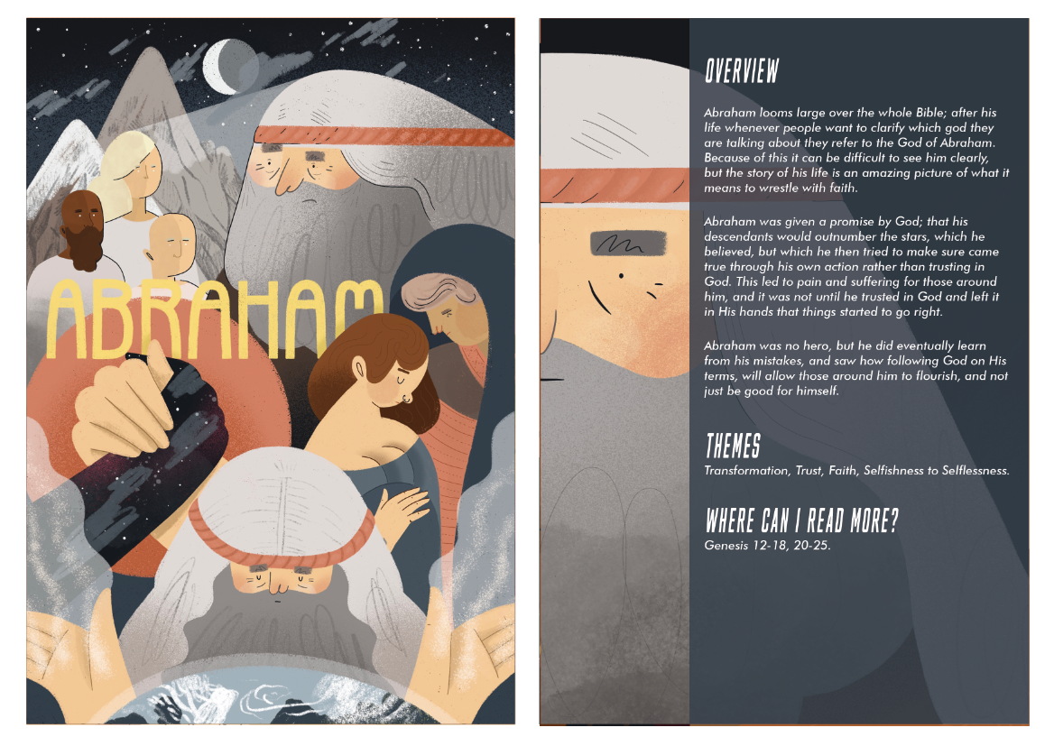

The course follows on from the “Faith Pictures” Lent Study Course that Revd Laura led for us. This new Study Course will look at the “Companions on our (Faith) Journey”, starting next Monday with Abraham when we will look at Hebrews 11:8-9; 17-19.

_____________________________________

2025 Church Annual Meetings

Please pray for the 2025 Annual Meetings of the three Churches in our Plurality, especially that willing nominees will be found for the posts that are to be filled by election.

The Brookfield 2025 Annual Meetings – the Meeting of Parishioners (to elect Churchwardens), and the Annual Parochial Church Meeting (APCM) will be held in Brookfield Church at
11.00am on Sunday 25th May 2025 immediately after the 9.30am service that day.

---*---

The Stainton with Hemlington 2025 Annual Meetings – the Meeting of Parishioners (to elect Churchwardens), and the Annual Parochial Church Meeting (APCM) – took place in Stainton Church at 12.00 noon on Sunday 11th May 2025 immediately after the 11.00am service that day. Here are details of the people elected, continuing or co-opted onto the new PCC:

Churchwardens: Vernon Clare (2025-2026) and Vacancy (2025-2026)
Deanery Synod Rep: Julia Ardley (2023-2026)
Lay Reps on the PCC: Jacqui Gedney and Petula Grimley (2025-2028)
Judith Clare and David Gatenby (2024-2027)
Bob Ardley and Joan Mason (2023-2026)
Angela Russell (2025-2026)

---*---

The Hilton 2025 Annual Meetings – the Meeting of Parishioners (to elect Churchwardens), and the Annual Parochial Church Meeting (APCM) – took place in Hilton Church at 2.00pm on Monday 12th May 2025. Here are details of the people elected, continuing or co-opted onto the new PCC:

Church wardens: Angela Sayer and Hilary Tulloch (2025-2026)
Deanery Synod Rep: Sally Hamlin (2023-2026)
Lay Reps on the PCC: Barbara Sowerby (2025-2028)
Trevor Turner and Gill Sheret (2024-2027)
Sylvia Booth (2023-2026)

_____________________________________

Services and Events in our Churches over the next two weeks
On Sunday 18th May 2025 – Easter 5 there will be services as follows:
At 9.30am at Hilton Church a service of Morning Praise, led by Julia Ardley, Parish Assistant;
At 9.30am at Brookfield Church a “Breakfast Church” service of informal worship with discussions, quizzes and simple refreshments [Editor’s note: there will NOT be Holy Communion at this service];
At 11.00am at Stainton Church a service of Holy Communion.
The lessons set in the Lectionary for Easter 5 are:
- Acts 11:1-18
- Psalm 148
- Revelation 21:1-6
- John 13:31-35
The Diocesan Reflection for Easter 5 is given by the Very Revd Dominic Barrington, Dean of York Minster. Dean Dominic reflects on the Gospel reading set in the Lectionary (John 13:31-35); you can find the Reflection at this link.

On Monday 19th May 2025 at 2.00pm at Brookfield Church (Hall) there is the first session of our new, fortnightly Plurality Bible Study “Companions on our Journey” when we shall be looking at Abraham. These study sessions are open to anyone from any of the three Churches in our Plurality, will last about one hour, and will be led by our Vicar, Revd Laura Wild.
On Tuesday 20th May 2025 at 9.30am at Stainton Church there will be a half-hour Plurality Prayer Gathering.
On Wednesday 21st May 2025 at 10.00am at Brookfield Church; there will be a service of Holy Communion at which our Vicar, Revd Laura Wild, will preside.
_____________________________________

On Sunday 25th May 2025 – Easter 6 – there will be services as follows:
At 9.30am at Brookfield Church a service of Holy Communion, followed by the Brookfield 2025 Annual Meetings;
At 11.00am at Stainton Church a service of Holy Communion; and
At 4.00pm at Hilton Church a service of Evensong
The lessons set in the Lectionary for Easter 6 are:
- Acts 16:9-15
- Psalm 67
- Revelation 21:10, 22 to 22:5
- John 13:23-29 or John 5:1-9
The Diocesan Reflection for the Easter 6 will be available on the Diocesan website at this link from about the Thursday of the previous week.

On Monday 26th May 2025 it is a Bank Holiday.
On Tuesday 27th May 2025 at 9.30am at Stainton Church there will be a half-hour Plurality Prayer Gathering.
On Wednesday 28th May 2025 at 10.00am at Brookfield Church there will be a service of Holy Communion
On Thursday 29th May 2025 is Ascension Day – details of the services in the Plurality will be confirmed shortly.
On Friday 30th May 2025 at 12.00 noon at Stainton Church there will be Prayer for Thy Kingdom Come.
On Saturday 31st May 2025 at 12.00 noon at Stainton Church there will be Prayer for Thy Kingdom Come.
_____________________________________

Please continue to pray

… for Myanmar and neighbouring Thailand

Pray for all those affected by the recent massive earthquake that occurred in Myanmar on Friday 28th March 2025: for the Military Junta in Myanmar; the success of the DEC Myanmar Earthquake Appeal, and all the humanitarian aid agencies seeking to support those in great need.

… for Israel, Palestine and Lebanon

The situation in Gaza has become catastrophic! We need as much specific prayer as possible. Please pray for;
- Hamas to release the remaining Israeli hostages as soon as possible
- A softening of Israel’s stance on Palestine and a willingness to negotiate constructively for an end to the war
- The opening up of the border crossings between Israel and Gaza, and for the resumption of humanitarian aid and relief to reach those who so desperately need it.

Here is a prayer from Ely Cathedral.

A Prayer for peace in Israel and Gaza
Heavenly Father, we pray for the many people whose lives have been torn apart by conflict in Gaza and Israel.

We pray especially those who have died, those who are grieving, the injured and those now without food, shelter or medical supplies. Strengthen and support the work of all relief organisations.

We pray also for those who have the power to bring peace. May they be touched by a spirit of compassion and kindness.

Lord, hear us as we pray in the power of your Spirit, through Jesus Christ our Lord.

Amen

…. and for Ukraine and Russia

For an early end to the war between Russia and Ukraine, giving thanks that talks are taking place and pray that there will be a satisfactory outcome to those talks which is acceptable to both sides.

_____________________________________

Please join us in praying for our Churches to Grow

Can we invite you to use our Revitalise "prayer for growth" in your personal quiet times with God?

Revitalise us Lord,
Enthuse in our congregations the desire for mission. Give
Vision to our planning and
Inspire our thoughts as we seek Your will.
Teach us to be more like You, Christ
Abiding in You and
Loving one another.
In growing healthy churches,
Sharing our faith, living Christ’s story
Every day, help us to be faithful disciples and bear much fruit. Amen.
_____________________________________

Pastoral Support - Here are the contact details for our Vicar, Revd Laura Wild:

Address: The Vicarage, 89 Low Lane, Brookfield, Middlesbrough TS5 9EF
Phone: 01642-598621
E-mail: rev.laura.wild@gmail.com

Laura's normal "day off" is Friday - if you need to contact her on that day please leave a message on the answerphone.
______________________________________

Bob Ardley

Ashdale House, 26 Meldyke Lane, Stainton, Middlesbrough TS8 9AU

T: 01642-284525
E: bob.ardley@ntlworld.com

