Greetings to Stainton and Hemlington Church Members and Friends of Stainton Church

Welcome to the Stainton Church e-News for

Friday 8th May 2025

We hope you are well and keeping safe. If you need any
practical support, please do get in touch.

(*) The next edition of the e-News will be sent out on Friday 9th May 2025

Apologies from your Editor!

Hopefully e-News Readers are aware that there are two versions of the Newsletter sent out each Friday, the Fancy Coloured Newsletter (FCN), which is sent out via MailChimp® and which some Readers never see because it arrives in their junk/spam folder; and a simple Outlook® e-mail version which hopefully ends up in the recipient’s InBox and so is readable by everyone. MailChimp tells your Editor that only 41 recipients read the FCN out of the 65 people to whom it was sent.

The last edition of the e-News was sent out on Friday 25th April 2025 just before your Editor went on holiday and in the last-minute rush the MailChimp® FCN was sent out but not the Outlook® version.

Your Editor sends his abject apologies to all the Readers who received the FCN in their junk/spam and so did not see the Newsletter that week.

_____________________________________

“Habemus Papam” – We have a (new) Pope!

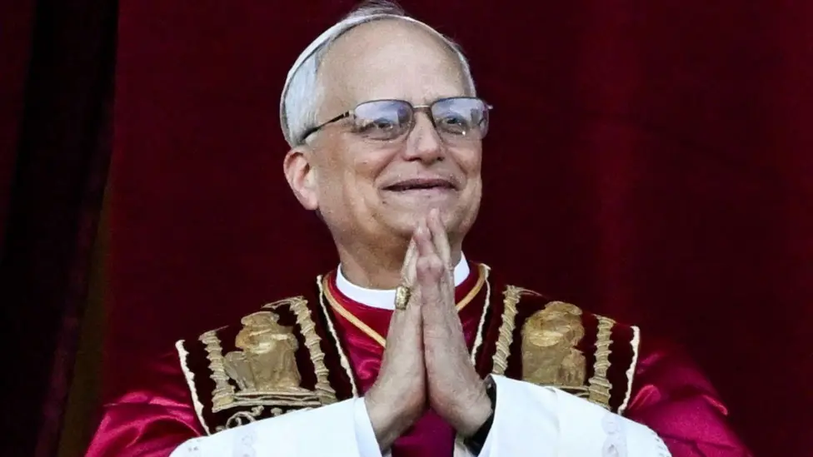
Picture credit: Reuters, via BBC.co.uk/News

Cardinal Robert Francis Prevost was elected as Pope Leo XIVth by the Conclave of Cardinals in the Vatican yesterday, Thursday 7th May 2025.

Please pray for Pope Leo as he takes up his new role as the Head of the Roman Catholic Church, and that he may be led by the Holy Spirit as he as he leads the nearly 1.4 billion Roman Catholic Christians in the seven continents - Asia, Africa, North America, South America, Antarctica, Europe, and Australia (listed from largest to smallest in size).
_____________________________________

WATCH TODAY
Private John Borland: A Special WWII Commemorative Film
Watch the remarkable true story of Private John Borland and how a single page of scripture sustained him through five years of unimaginable hardship as a prisoner of war.
Retold by his daughter Margaret Borland, Private John Borland: A Special WWII Commemorative Film is a powerful testament of the faith of a young soldier during World War Two. In partnership with Hope Together, this film was produced by Lumo Project Films and Bible Media Group.
On Thursday this past week, 8th May 2025, we marked the 80th anniversary of VE Day [and now] we invite you to share this powerful testimony from World War II with your friends, family, and on social media, so that many more can hear this inspiring story of hope and faith.

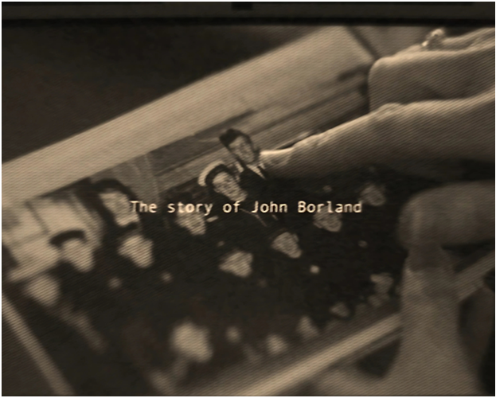

To watch this short film – it is just under 7-minutes long – please just click on the picture above to view the YouTube video.

_____________________________________

2025 Church Annual Meetings

Please pray for the 2025 Annual Meetings of the three Churches in our Plurality, especially that willing nominees will be found for the posts that are to be filled by election.

The Stainton with Hemlington 2025 Annual Meetings – the Meeting of Parishioners (to elect Churchwardens), and the Annual Parochial Church Meeting (APCM) will be held in Stainton Church at
12.00 noon on Sunday 11th May 2025 immediately after the 11.00am service that day.

The Hilton 2025 Annual Meetings – the Meeting of Parishioners (to elect Churchwardens), and the Annual Parochial Church Meeting (APCM) will be held in Hilton Church at
2.00pm on Monday 12th May 2025.

The Brookfield 2025 Annual Meetings – the Meeting of Parishioners (to elect Churchwardens), and the Annual Parochial Church Meeting (APCM) will be held in Brookfield Church at
11.00am on Sunday 25th May 2025 immediately after the 9.30am service that day.

_____________________________________

Services and Events in our Churches over the next two weeks
On Sunday 11th May 2025 – Easter 4 – there will be services as follows:
At 9.30am at Brookfield Church a service of Holy Communion;
At 11.00am at Stainton Church a service of Holy Communion, followed by the Stainton 2025 Annual Meetings; and
At 4.00pm at Hilton Church a service of Evensong
The lessons set in the Lectionary for Easter 4 are:
- Acts 9:36-43
- Psalm 23
- Revelation 7:9-17
- John 10:22-30
The Diocesan Reflection for Easter 4 is given by the Venerable Dr Amanda Bloor, Archdeacon of Cleveland. Archdeacon Amanda reflects on the Gospel reading set in the Lectionary (John 10:22-30); you can find the Reflection at this link.

On Monday 12th May 2025 at Hilton Church at 2.00pm there will be the Hilton 2025 Annual Meetings.
On Tuesday 13th May 2025 at 9.30am at Stainton Church there will be a half-hour Plurality Prayer Gathering.
On Wednesday 14th May 2025 at 10.00am at Brookfield Church there will be a service of Holy Communion
_____________________________________
On Sunday 18th May 2025 – Easter 5 there will be services as follows:
At 9.30am at Hilton Church a service of Morning Praise, led by Julia Ardley, Parish Assistant;
At 9.30am at Brookfield Church a “Breakfast Church” service of informal worship with discussions, quizzes and simple refreshments [Editor’s note: there will NOT be Holy Communion at this service];
At 11.00am at Stainton Church a service of Holy Communion.
The lessons set in the Lectionary for Easter 5 are:
- Acts 11:1-18
- Psalm 148
- Revelation 21:1-6
- John 13:31-35
The Diocesan Reflection for the Easter 5 will be available on the Diocesan website at this link from about the Thursday of the previous week.

On Tuesday 20th May 2025 at 9.30am at Stainton Church there will be a half-hour Plurality Prayer Gathering.
On Wednesday 21st May 2025 at 10.00am at Brookfield Church; there will be a service of Holy Communion at which our Vicar, Revd Laura Wild, will preside.
_____________________________________
On Sunday 25th May 2025 – Easter 6 – there will be services as follows:
At 9.30am at Brookfield Church a service of Holy Communion, followed by the Brookfield 2025 Annual Meetings;
At 11.00am at Stainton Church a service of Holy Communion; and
At 4.00pm at Hilton Church a service of Evensong
_____________________________________

Please continue to pray

… for Myanmar and neighbouring Thailand

Pray for all those affected by the recent massive earthquake that occurred in Myanmar on Friday 28th March 2025: for the Military Junta in Myanmar; the success of the DEC Myanmar Earthquake Appeal, and all the humanitarian aid agencies seeking to support those in great need.

… for Israel, Palestine and Lebanon

Please pray for a resumption of the ceasefire between Israel and Hamas; and a rapid progress of the negotiations between Israel and Hamas and the other intermediaries that will lead to a lasting peace and co-existence for the Israeli and Palestinian peoples.

…. and for Ukraine and Russia

For an early end to the war between Russia and Ukraine, giving thanks that talks are taking place and pray that there will be a satisfactory outcome to those talks which is acceptable to both sides.

_____________________________________

Please join us in praying for our Churches to Grow

Can we invite you to use our Revitalise "prayer for growth" in your personal quiet times with God?

Revitalise us Lord,
Enthuse in our congregations the desire for mission. Give
Vision to our planning and
Inspire our thoughts as we seek Your will.
Teach us to be more like You, Christ
Abiding in You and
Loving one another.
In growing healthy churches,
Sharing our faith, living Christ’s story
Every day, help us to be faithful disciples and bear much fruit. Amen.
_____________________________________

Pastoral Support - Here are the contact details for our Vicar, Revd Laura Wild:

Address: The Vicarage, 89 Low Lane, Brookfield, Middlesbrough TS5 9EF
Phone: 01642-598621
E-mail: rev.laura.wild@gmail.com

Laura's normal "day off" is Friday - if you need to contact her on that day please leave a message on the answerphone.
______________________________________

Bob Ardley

Ashdale House, 26 Meldyke Lane, Stainton, Middlesbrough TS8 9AU

T: 01642-284525
E: bob.ardley@ntlworld.com

