Greetings to Stainton and Hemlington Church Members and Friends of Stainton Church

Welcome to the two-week edition (*) of the Stainton Church e-News for

Friday 25th April 2025

We hope you are well and keeping safe. If you need any
practical support, please do get in touch.

(*) The next edition of the e-News will be sent out on Friday 9th May 2025

Praise God for the life and service of Pope Francis who
died this past week


Pope Francis. (Credit: Alfredo Borba, Wikimedia Commons)

Your Editor is pleased to quote from the Christian Charity Embrace the Middle East which says:

Dear Friends
We join with our sisters and brothers across the world in mourning the death of Pope Francis, a courageous global voice for justice, compassion, and peace.
Pope Francis had a heart attuned to the cries of the oppressed. From Lebanon to Syria, Iraq to Israel and Palestine, he never ceased to pray, speak out, and act on behalf of those suffering injustice, violence and poverty. We give thanks for his extraordinary witness and pray that he may rest in peace.
_____________________________________

2025 Stainton Church Annual Meetings

The Stainton with Hemlington 2025 Annual Meetings – the Meeting of Parishioners (to elect Churchwardens), and the Annual Parochial Church Meeting (APCM) will be held in Stainton Church at
12.00 noon on Sunday 11th May 2025 immediately after the 11.00am service that day.

News from Revd Marie Edwards

Marie writes: As many of you know I have spent the majority of my working life caring for young children, mainly those aged 5 years and under. I decided towards the end of 2024 that it was time to have a complete change. I left work at Christmas time and started looking into new opportunities. My heart has two loves (outside of my family), caring for children and the church. I replied to lots of job adverts, receiving both set backs and offers of interviews. One of the interviews was for a Chaplain for one of the many colleges that make up Durham University. I filled out the application form, added the necessary documents and pressed send!!

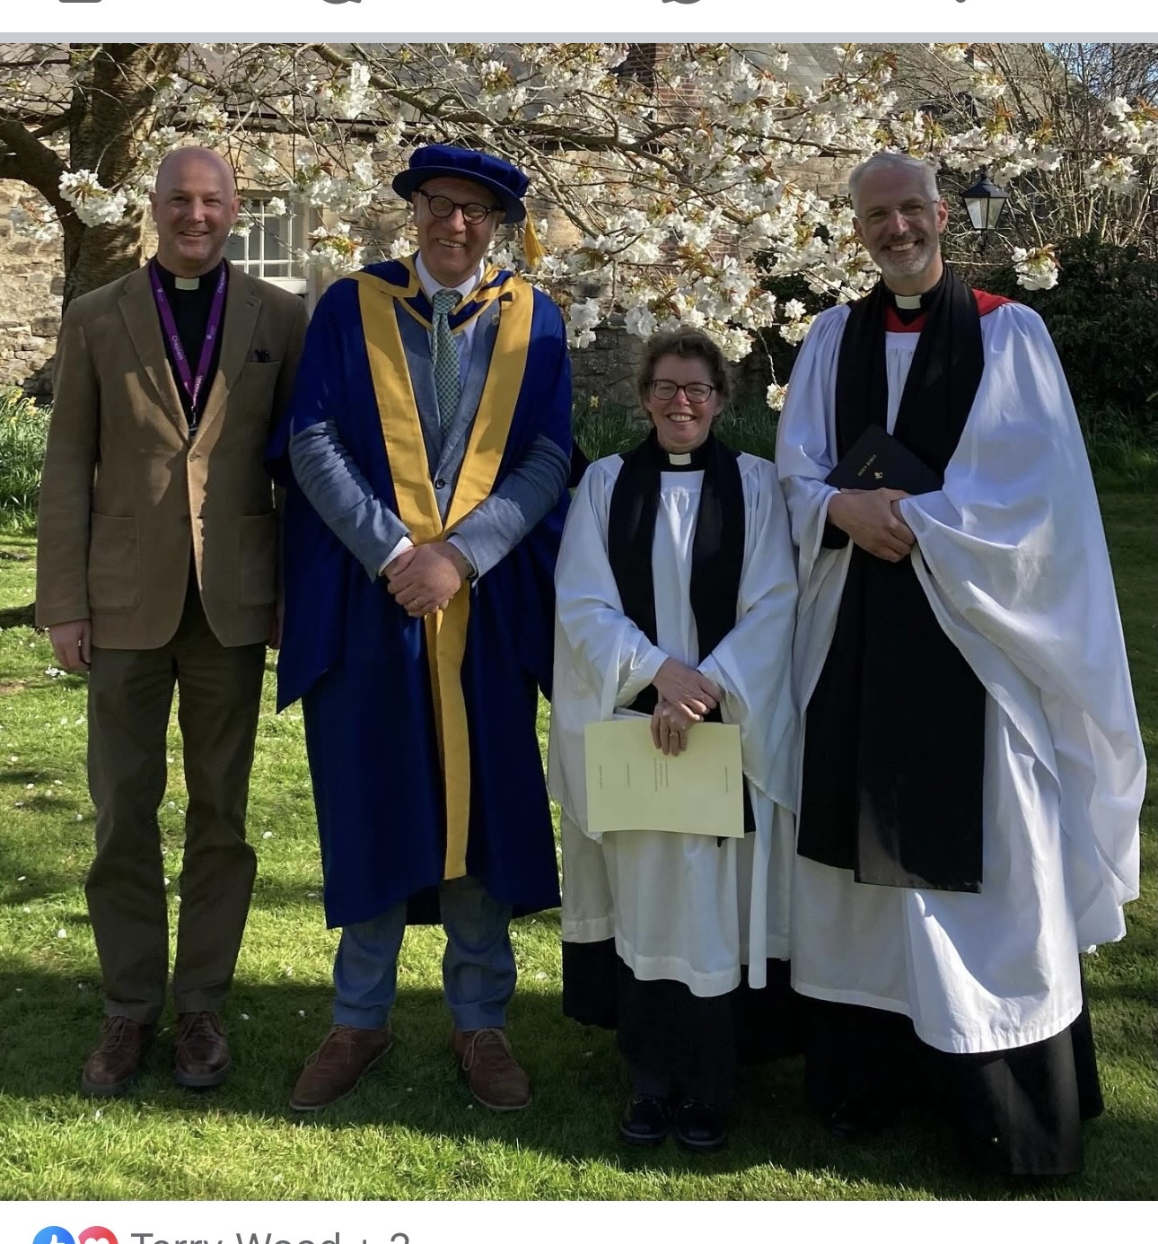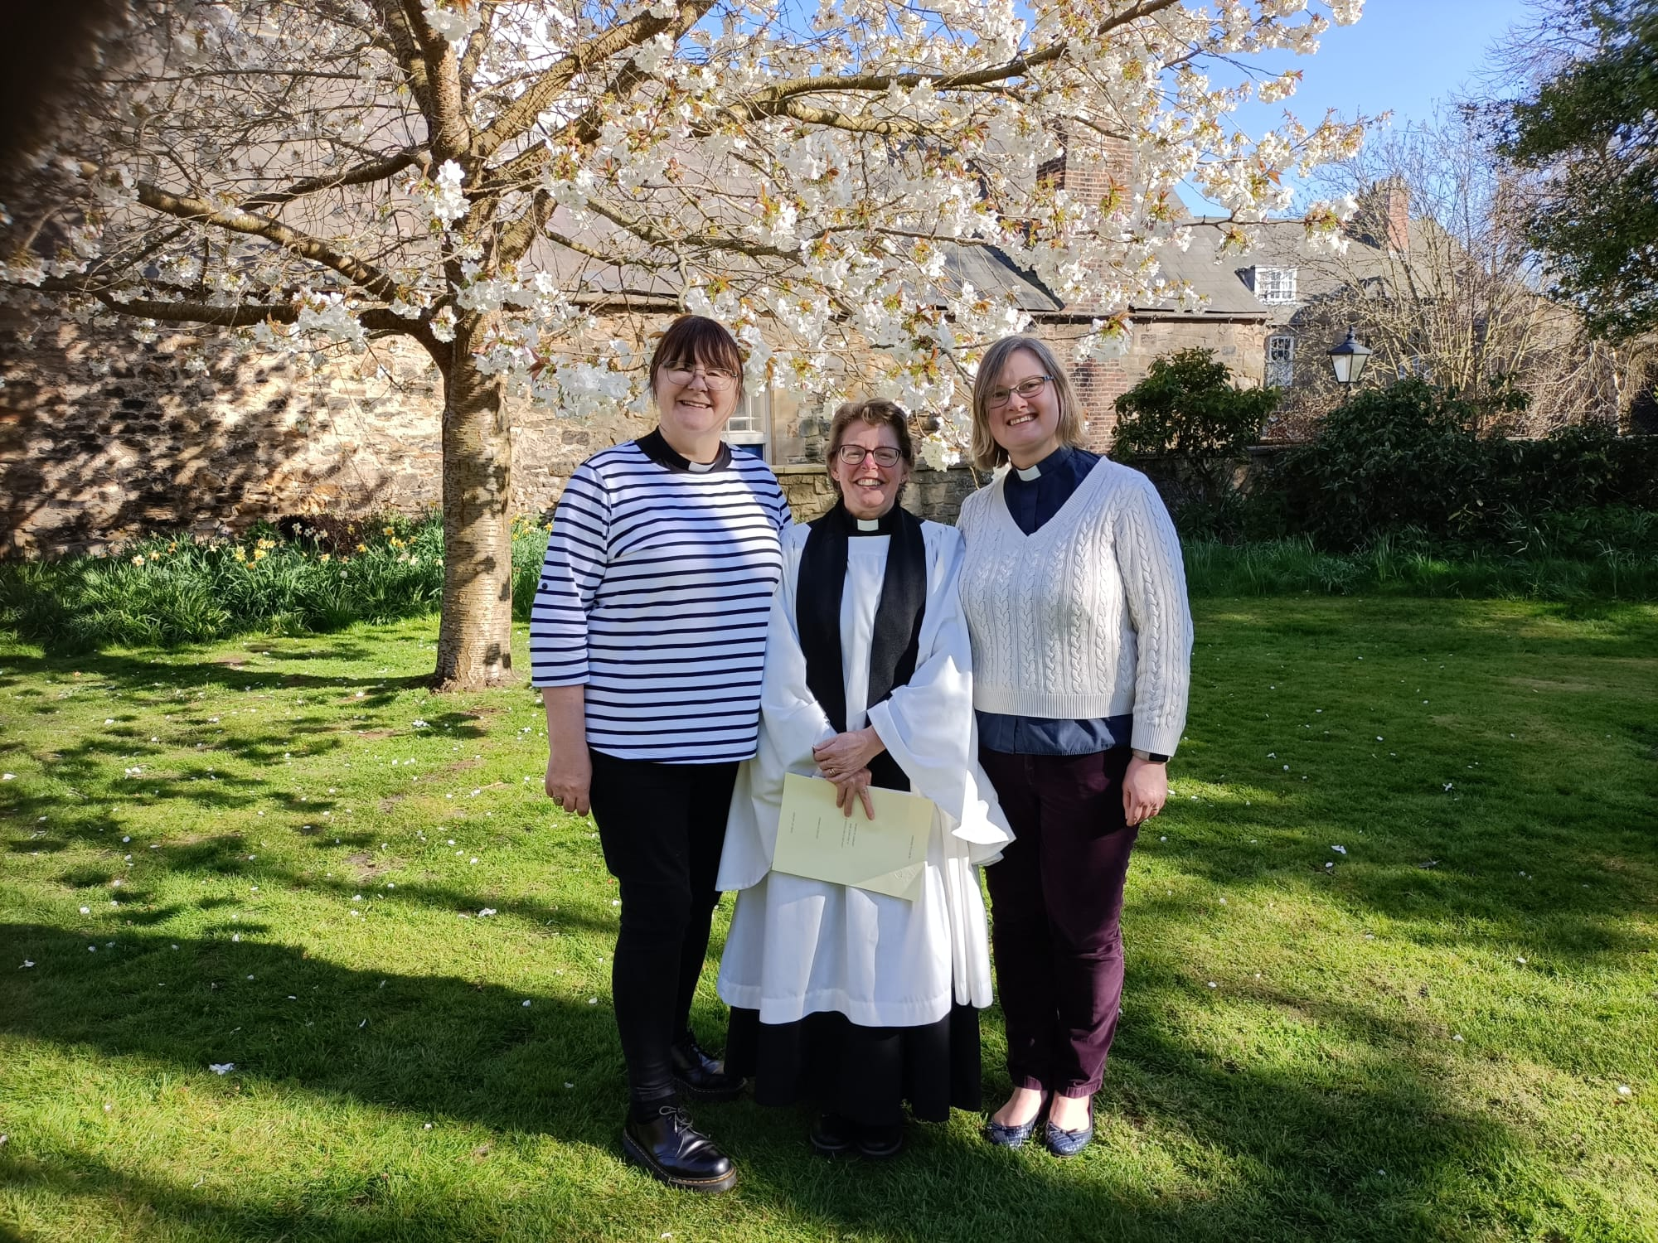

I went for the interview early in 2025 and a few weeks later received the news that they wanted to offer me the role! I will be the Chaplain for Hild Bede College at Durham University. My learning curve I feel will go at a steep angle, but I am looking forward to the challenge and the opportunity to support the staff and students at the University. I have already met many of the people I will be working with and they seem lovely.

The three men in the first photo above are (from left to right):
- Revd Gavin Wort, Lead Chaplain for the University;
- Simon Forrest, Principal of the Hild Bede College; and
- The Very Revd Dr Philip Plyming, Dean of Durham Cathedral

The only sad part [of my move to this new job] is the fact that I will be doing Sunday services in Durham so I will not be able to take as many services within the plurality. However, you do not get rid of me that easily and I look forward to being able to come and help out as soon as I get myself embedded properly at Durham. There will be a Welcoming Service at some point in Durham to which I hope to invite people from the Plurality to come along to if they are able to do so. I want to say thank you so much to everyone for all the support, care and love I have received as part of this wonderful set of churches. I especially want to say thank you to Rev Laura for allowing me to come and help out, for enabling me to grow and learn both professionally and personally within my faith; and Rev Vanessa for the listening ear and caring nature she has shown me.

I will miss seeing everyone on a regular basis, but I promise to pop in and out whenever possible. Many thanks again to each and every one of you.

With love and prayers

Marie
_____________________________________

Services and Events in our Churches over the next three weeks
On Sunday 27th April 2025 – the second Sunday (Easter 2) – there will be services as follows:
At 9.30am at Brookfield Church a service of Holy Communion;
At 11.00am at Stainton Church a service of Holy Communion; and
At 4.00pm at Hilton Church a service of Evensong
The lessons set in the Lectionary for Easter 2 are:
- Acts 5:27-35
- Psalm 118:14-29 or Psalm 150
- Revelation 1:4-8
- John 20:19-31
The Diocesan Reflection for Easter 2 is given by the Venerable Andy Broom, Archdeacon of the East Riding. Archdeacon Andy reflects on the Gospel reading set in the Lectionary (John 20:19-31); you can find the Reflection at this link.

On Tuesday 29th April 2025 at 9.30am at Stainton Church there will be a half-hour Plurality Prayer Gathering.
On Wednesday 30th April 2025 at 10.00am at Brookfield Church there will be a service of Holy Communion
_____________________________________
On Sunday 4th May 2025 – Easter 3 there will be services as follows:
At 9.30am at Hilton Church a service of Holy Communion;
At 9.30am at Brookfield Church a service of Holy Communion; and
At 11.00am at Stainton Church a Café Church service of informal worship with discussions, quizzes and simple refreshments [Editor’s note: there will NOT be Holy Communion at this service]
The lessons set in the Lectionary for Easter 3 are:
- Acts 9:1-6 [and 7-20]
- Psalm 30
- Revelation 5:11-14
- John 21:1-19
The Diocesan Reflection for the Easter 3 will be available on the Diocesan website at this link from about the Thursday of the previous week.

On Tuesday 6th May 2025 at 9.30am at Stainton Church there will be a half-hour Plurality Prayer Gathering.
On Wednesday 7th May 2025 at 10.00am at Brookfield Church; there will be a service of Holy Communion at which our Vicar, Revd Laura Wild, will preside.
_____________________________________
On Sunday 11th May 2025 – Easter 4 – there will be services as follows:
At 9.30am at Brookfield Church a service of Holy Communion;
At 11.00am at Stainton Church a service of Holy Communion, followed by the Stainton 2025 Annual Meetings; and
At 4.00pm at Hilton Church a service of Evensong
The lessons set in the Lectionary for Easter 4 are:
- Acts 9:36-43
- Psalm 23
- Revelation 7:9-17
- John 10:22-30
The Diocesan Reflection for the Easter 4 will be available on the Diocesan website at this link from about the Thursday of the previous week.

On Monday 12th May 2025 at 2.00pm at Hilton Church there will be the Hilton 2025 Annual Meetings
On Tuesday 13th May 2025 at 9.30am at Stainton Church there will be a half-hour Plurality Prayer Gathering.
On Wednesday 14th May 2025 at 10.00am at Brookfield Church there will be a service of Holy Communion
_____________________________________

Please continue to pray

… for Myanmar and neighbouring Thailand

Pray for all those affected by the recent massive earthquake that occurred in Myanmar on Friday 28th March 2025: for the Military Junta in Myanmar; the success of the DEC Myanmar Earthquake Appeal, and all the humanitarian aid agencies seeking to support those in great need.

… for Israel, Palestine and Lebanon

Please pray for a resumption of the ceasefire between Israel and Hamas; and a rapid progress of the negotiations between Israel and Hamas and the other intermediaries that will lead to a lasting peace and co-existence for the Israeli and Palestinian peoples.

…. and for Ukraine and Russia

For an early end to the war between Russia and Ukraine, giving thanks that talks are taking place and pray that there will be a satisfactory outcome to those talks which is acceptable to both sides.

_____________________________________

Please join us in praying for our Churches to Grow

Can we invite you to use our Revitalise "prayer for growth" in your personal quiet times with God?

Revitalise us Lord,
Enthuse in our congregations the desire for mission. Give
Vision to our planning and
Inspire our thoughts as we seek Your will.
Teach us to be more like You, Christ
Abiding in You and
Loving one another.
In growing healthy churches,
Sharing our faith, living Christ’s story
Every day, help us to be faithful disciples and bear much fruit. Amen.
_____________________________________

Pastoral Support - Here are the contact details for our Vicar, Revd Laura Wild:

Address: The Vicarage, 89 Low Lane, Brookfield, Middlesbrough TS5 9EF
Phone: 01642-598621
E-mail: rev.laura.wild@gmail.com

Laura's normal "day off" is Friday - if you need to contact her on that day please leave a message on the answerphone.
______________________________________

Bob Ardley

Ashdale House,
26 Meldyke Lane,
Stainton,
Middlesbrough TS8 9AU

T: 01642-284525;
E: bob.ardley@ntlworld.com

