Greetings to Stainton and Hemlington Church Members and Friends of Stainton Church

Welcome to the Stainton Church e-News for
Friday 8th December 2023
We hope you are well and keeping safe. If you need any
practical support please do get in touch.

Getting ready for Christmas?


Our Vicar, Revd Laura Wild is leading a short Advent Study course to help us prepare for our celebration of Christmas. It is not too late to join in with the last sessions which will look at Simeon's "Song of Hope", the Nunc Dimittis, found in Luke 2:29-32 and will be:
- on Monday evening from 7.00 - 8.00pm in the Brookfield Church Lounge on the 11th December 2023; and
- on Tuesday afternoon from 2.00 - 3.00pm in Stainton Church Parish Room on the 12th December 2023.
The Study sessions, which are self-contained, are open to all – do come and join with others for a time of fellowship as we hear afresh about these key characters in the Christmas Story (Zechariah, Mary and - this week - Simeon).
In the second session discovered afresh the Magnificat. We learnt about Mary and her encounter with the Angel Gabriel and the impact his message had on her. Mary travelled to visit her cousin Elizabeth who, even her old age, was pregnant with the boy of whom Zechariah would, in due course, declare: "His name is JOHN!"
When Elizabeth heard Mary's greeting, "the child leapt in her womb [...] and she was filled with the Holy Spirit" (Luke 1:41). This reassured Mary that what Gabriel had said to her really was true. And we were reminded that although Joseph had initially decided to dismiss (divorce) Mary quietly, after his encounter with the Angel he took Mary to be his wife (Matthew 1:19, 24).
This second study session prompts your Editor to share with you two versions of a tremendous worship song about Mary called: "Mary, Did You Know?"
The first version is sung by a group called Pentatonix and the video has the lyrics so that you can follow as you listen to the music (Readers of the printed e-News will also receive a printed copy of the lyrics).
The second version is from a group of Messianic Jews called One for Israel who say: "We produced a series of music videos to celebrate the birth of our Messiah Yeshua. No matter when you celebrate, our passion is to point people to the narrative of salvation and find unity in worshiping our King Messiah"; this is so apt in the light of the current Israeli-Hamas war. This version of the song is at times in English, at times in Arabic, and at times in Hebrew, but all along the lyrics are displayed in English so the viewer can follow.
To watch the videos just click on the "play" button (you may have to wait a few seconds in each case to skip the adverts!).

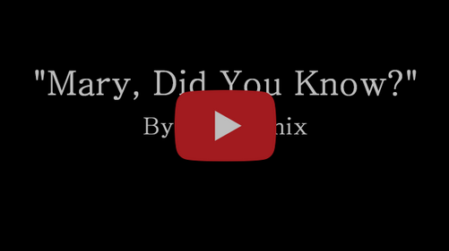

A Lyric Video to accompany a recording of "Mary, Did You Know?" by Pentatonix.
Source: https://www.youtube.com/watch?v=cZVjXsf_7aI

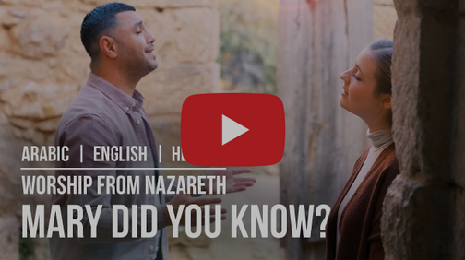

A Lyric Video in English with soundtrack in English, Arabic and Hebrew,
and some stunning video images of Mary and Joseph ... and watch out for the donkey!
Source: https://www.youtube.com/watch?v=k7tfBYESaoo

____________________________________

Services and Events in our three Parishes during Advent and Christmas 2023

We have published on the Plurality website a list of all the services and events taking place in our three Parishes over the Advent and Christmas period. You can find the list at this link.

____________________________________

Services in our Churches over the next two weeks

On Sunday 10th December 2023 – the Second Sunday of Advent the will be services as follows:

At 8.00m at Hilton Church - a service of Holy Communion at which our Vicar, Revd Laura Wild will preside;

At 9.30am at Brookfield Church - a service of Holy Communion at which our Vicar will also preside;

At 11.00am at Stainton Church - a service of Holy Communion at which Revd Marie Edwards will preside; and

At 4.00pm at Brookfield Church - a Plurality Christingle service led by our Vicar.

The lessons set for the Advent 2 are:
- Isaiah 40:1-11
- Psalm 85:1-2, 8-13
- 2 Peter 3:8-15a
- Mark 1:1-8

The Diocesan Reflection for the Second Sunday of Advent is given by the Rt Revd Dr Eleanor Sanderson, Bishop of Hull. Bishop Eleanor reflects on the Gospel set for the Second Sunday of Advent (Mark 1:1-8). The Reflection can be found at this link.

On Monday 11th December 2023 at 7.00pm at Brookfield Church Lounge there will be the third and last session of the Songs of Advent Study course when we shall learn about Simeon and the Nunc Dimittis.

On Tuesday 12th December 2023 at 9.30am at Stainton Church there will be a half-hour Prayer Gathering.

On Tuesday 12th December 2023 at 2.00pm at Stainton Church there will be the third and last session of the Songs of Advent Study course when we shall learn about Simeon and the Nunc Dimittis.

On Wednesday 13th December 2023 at 10.00am at Brookfield Church there will be a service of Holy Communion at which the Vicar, Revd Laura Wild, will preside.

On Wednesday 13th December 2023 at 7.30pm in the Stainton Memorial Hall there will be a Stainton Village Carol service … this is a joint venture between Stainton Parish Church and Stainton Methodist Chapel and will be led by the Methodist Minister, Revd David Godfrey and our Vicar, Revd Laura Wild.

On Friday 15th December 2023 at 7.00pm in Hilton Church there will be a Hilton Village Carol service led by our Vicar, Revd Laura Wild.

_____________________________________

On Sunday 17th December 2023 – Third Sunday of Advent

There will be services in our three Churches as follows:

At 9.30am at Hilton Church – a service of Morning Praise led by Julia Ardley, Lay Minister at Stainton;

At 9.30am at Brookfield Church – a service of Holy Communion led by our vicar, Revd Laura Wild; and

At 11.00am at Stainton Church – a non-Eucharistic Community Service of “Carols and Coffee”, also led by our Vicar, Revd Laura Wild.

The lessons set for the Advent 3 are:
- Isaiah 61:1-4 and 8-end
- Psalm 126
- 1 Thessalonians 5:16-24
- John 1:6-8 and 19-28 (NOT Mark 13:24-end as given in the MailChimp Fancy Coloured Newsletter!!!!)

The Diocesan Reflection for Advent 3 will be available at this link in due course, from about the Thursday of the preceding week.

On Tuesday 19th December 2023 at 9.30am at Stainton Church there will be a half-hour Prayer Gathering.

On Wednesday 20th December 2023 at 10.00am at Brookfield Church there will be a service of Holy Communion at which the Vicar, Revd Laura Wild, will preside.

On Wednesday 20th December 2023 at 5.00pm there will be an Open-Air Carol Service in the Town Square at the Viewley Centre in Hemlington, adjacent to the site of the former St Timothy’s Church, led by our Vicar, Revd Laura Wild.
____________________________________

Do you need some inspiration for praying each day?

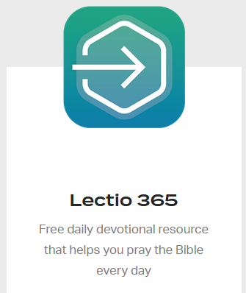
Your Editor, at his wife’s suggestion, can recommend the Lectio 365 App which is a free daily devotional App, published by the charity “24-7 Prayer” that helps you pray the Bible every day.

The App is available for iPhone and Android devices. To download your copy of the Lectio 365 App just click on the relevant image below:



____________________________________

Please continue to pray …..

… for Israel and Palestine  

For the war which is causing so much loss of life and destruction. Give thanks for the recent temporary truce in hostilities with the exchange of Hamas hostages and Israeli prisoners, and the supplies of aid allowed into Gaza. Pray for a complete end to the war as soon as possible.

Here is a prayer from the charity 24-7 Prayer:

A prayer for peace
You can simply pray this prayer or you can use each point as the basis for extended intercession.
God of all nations, we pray today for Israel and Gaza.

We pray for those grieving the sudden loss of loved ones, captives, and those whose homes have been destroyed.

We pray for a miraculous de-escalation of this conflict, asking for reason to overcome rage and revenge. We also ask that other nations will be restrained from escalating this situation further.

We pray for effective international peacemaking, seeking diplomacy over warmongering on all sides. Blessed are the merciful and the peacemakers. (Matthew 5:7, 9)

Amen.

…. and for Ukraine 

Pray for an end to the war between Russia and Ukraine.

Here is prayer also from 24-7Prayer:

Father God, King of all nations, we cry out to you now for the people of Ukraine. We ask you to rescue those who are vulnerable from the hands of their enemies that they may live without fear before you all their days [Luke 1:74-75].

Lord of lords and Prince of peace, our politicians are predicting the biggest war in Europe since 1945, and we simply cry out to you urgently to write another story in our time. Thwart the dark machinations of evil men. Give wisdom beyond human wisdom to peacemakers seeking an equitable and less violent way. May politicians exercise the wisdom from above, which is peaceable, gentle, willing to yield, and full of mercy [James 3:17].

Holy Spirit, we pray for the church in Ukraine, a nation in which 70% of the population call themselves Christian. Give our many brothers and sisters in that nation courage in this crisis that they may proclaim the good news of your kingdom, bind up broken hearts, and bring comfort to all who mourn. [Isaiah 61:1-2].

You Lord, make wars cease to the end of the earth; you break bows, shatter spears, and burn shields with fire [Psalm 46:9]. And so we ask you now to save the lives of many people in Ukraine. Make a peace that is strong and not weak. De-escalate this crisis. We hear of wars and rumours of wars (Matt. 24:6], but you Lord are our rock, our fortress and our deliverer. Our hope is in you. And so we address the nations now. In the name of Jesus we say: “Be still and know God! He is exalted among the nations; he shall be exalted in the earth [Psalm 46:10].

Amen
__________________________________
Leading Your Church into Growth
Can we remind you that it would be really good to use the LYCiG "prayer for growth" in your personal quiet times with God?

God of mission, Who alone brings growth to your Church, send your Holy Spirit to give:
- Vision to our planning,
- Wisdom to our actions,
- Joy to our worship, and
- Power to our witness.

Help our church to grow in numbers, in spiritual commitment to You and in service to our local community, through Jesus Christ our Lord. Amen

______________________________________

Pastoral Support

Here are the contact details for our Vicar, Revd Laura Wild

Address: The Vicarage, 89 Low Lane, Brookfield, Middlesbrough TS5 9EF
Phone: 01642-598621
E-mail: rev.laura.wild@gmail.com

Laura's normal "day off" is Friday - if you need to contact her on that day please leave a message on the answerphone.

Note: For the month of December 2023 Laura will be taking her day off on Saturdays
______________________________________

With all good wishes to you

Bob Ardley

Ashdale House,
26 Meldyke Lane,
Stainton,
Middlesbrough TS8 9AU

Tel: 01642-284525
E-mail: bob.ardley@ntlworld.com

