Greetings to Stainton and Hemlington Church Members and Friends of Stainton Church

Welcome to the Stainton Church e-News for
Friday 17th November 2023
We hope you are well and keeping safe. If you need any
practical support please do get in touch.

Getting ready for Christmas?


Our Vicar, Revd Laura Wild is pleased to announce that she will be running a short Advent Study course to help us prepare for our celebration of Christmas. The course will be held over three weeks and will draw on the material in the “Songs of Advent” which was previously published in the magazine Christianity Today. The Study sessions will run:

- on Monday evenings from 7.00 - 8.00pm in the Brookfield Church Lounge on the 27th November, 4th December and 11th December 2023; and
- on Tuesday afternoons from 2.00 - 3.00pm in Stainton Church Parish Room on the 28th November, 5th December and 12th December 2023.

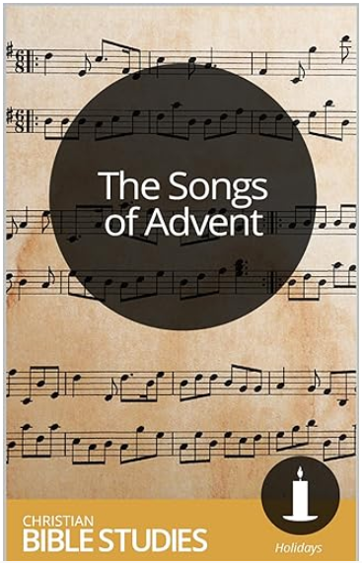
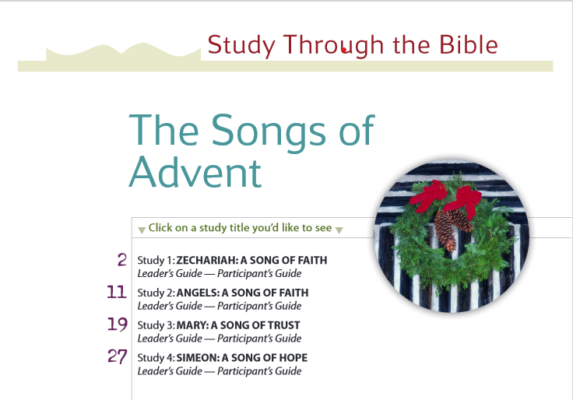

The three sessions will look at:
- A song of faith – Zechariah (Luke 1:67-79);
- A song of trust – Mary (Luke 1:46-55); and
- A song of hope – Simeon (Luke 2:29-32).

The Study sessions are open to all – do come and join with others for a time of fellowship as we hear afresh about these key characters in the Christmas Story.

____________________________________

Services in our Churches over the next two weeks

On Sunday 19th November 2023 – the Second Sunday before Advent – there will services as follows:

at 9.30am at Hilton Church - a service of Morning Praise, led by Julia Ardley, Lay Minister at Stainton;

at 9.30am at Brookfield Church - a Patronal Festival service of Holy Communion to celebrate St Margaret of Scotland at which the Vicar, Revd Laura Wild will preside; and

at 11.00am at Stainton Church - a service of Holy Communion at which the Vicar, Revd Laura Wild, will also preside.

The lessons set for the Second Sunday before Advent are:
- Zephaniah 1:7, 12-18;
- Psalm 90:1-12
- 1 Thessalonians 5:1-11
- Matthew 25:14-30

The Diocesan Reflection for the Second Sunday before Advent is given by our Archdeacon of Cleveland, the Venerable Dr Amanda Bloor. Archdeacon Amanda reflects on the Gospel set for the day (Matthew 25:14-30). The Reflection can be found at this link.

On Tuesday 21st November 2023 at 9.30am at Stainton Church there will be a half-hour Prayer Gathering.

On Wednesday 22nd November 2023 at 10.00am at Brookfield Church there will be a service of Holy Communion at which the Vicar, Revd Laura Wild, will preside.
____________________________________

On Sunday 26th November 2023 – Christ the King (The Sunday next before Advent) the services in each of our three Churches will include an opportunity for those attending to bring donations of unwrapped toys/gifts; these will be donated to a Teesside Christmas Gift Appeal which will provide Christmas presents to those Children (and some adults?) who, because of their family circumstances, would not be receiving a Christmas gift this year. There will be services at which the Vicar, Revd Laura Wild will preside as follows:

At 9.30am at Brookfield Church a service of Holy Communion;

At 10.45am at Stainton Church a service of Holy Communion; and

At 4.00pm at Hilton Church a service of Evensong.

The lessons set for the Christ the King are:
- Ezekiel 34:11-16, 20-24
- Psalm 95:1-7
- Ephesians 1:15-end
- Matthew 25:31-end

The Diocesan Reflection for Christ the King will be available at this link in due course, from about the Thursday of the preceding week.

On Monday 27th November 2023 at 7.00pm at Brookfield Church Lounge there will be the first session of the Songs of Advent Study course.

On Tuesday 28th November 2023 at 9.30am at Stainton Church there will be a half-hour Prayer Gathering.

On Tuesday 28th November 2023 at 2.00pm at Stainton Church there will be the first session of the Songs of Advent Study course.

On Wednesday 29th November 2023 at 10.00am at Brookfield Church there will be a service of Holy Communion at which the Vicar, Revd Laura Wild, will preside.

_____________________________________

Please continue to pray …..

… for Israel and Palestine  

For the war which is causing so much loss of life and destruction.

…. and for Ukraine 

Pray for an end to the war between Russia and Ukraine.
__________________________________
Leading Your Church into Growth
Can we remind you that it would be really good to use the LYCiG "prayer for growth" in your personal quiet times with God?

God of mission, Who alone brings growth to your Church, send your Holy Spirit to give:
- Vision to our planning,
- Wisdom to our actions,
- Joy to our worship, and
- Power to our witness.

Help our church to grow in numbers, in spiritual commitment to You and in service to our local community, through Jesus Christ our Lord. Amen

______________________________________

Pastoral Support

Here are the contact details for our Vicar, Revd Laura Wild

Address: The Vicarage, 89 Low Lane, Brookfield, Middlesbrough TS5 9EF
Phone: 01642-598621
E-mail: rev.laura.wild@gmail.com

Laura's normal "day off" is Friday - if you need to contact her on that day please leave a message on the answerphone.

Note: For the month of December 2023 Laura will be taking her day off on Saturdays
______________________________________

With all good wishes to you

Bob Ardley

Ashdale House,
26 Meldyke Lane,
Stainton,
Middlesbrough TS8 9AU

Tel: 01642-284525
E-mail: bob.ardley@ntlworld.com

