Happy New Year Greetings to Stainton Church Members and Friends of Stainton Church
Welcome to the weekly e-News for Friday 1st January 2021
The Church Commissioners have published a draft Pastoral Scheme to re-unite Hemlington and Stainton; please see below for details.
We hope you are well and keeping safe, and are surviving the latest Covid19 lockdown. If you need any practical support please do get in touch.
From 00.01hrs on Thursday 31st December 2020 the Middlesbrough and Stockton areas are in Covid Tier 4 and people are asked to stay at home as much as possible; however, our Covid-safe Churches remain open for Corporate Worship and we look forward to welcoming you - you may attend as households; are asked to wear a face covering; and asked not to mingle before or after the service.

Clergy Support
Revd Claire Todd, our Parish Priest, is on holiday at home for a few days although she will be taking the services on Sunday 3rd January (see below for details). If you need the support of a Priest please do contact Claire:
Phone: 01642-294582
E-mail: revtoddy@gmail.com
If you ring Claire then you can leave a message on her answerphone and she can return your call in due course.

Services in our Churches
Our Parish Priest Claire Todd will lead our Services of Holy Communion on Sunday 3rd January 2021 to celebrate the (transferred) Feast of the Epiphany at 9.30am at Brookfield and at 11.00am at Stainton.
On Wednesday 6th January 2021 (Epiphany-proper!) at 10.00am there will be a service of Ante-Communion at Brookfield, led by Joan Mason.
Hilton: The Church remains closed for the time being – Claire and Hilton PCC are considering if and when the Church can re-open.
(*) You can find the St Margaret of Scotland, Brookfield Facebook page at this link.
If you are unable to join us for the services in Church this Sunday 3rd January 2021 (Epiphany) please do use the sheet for worship-at-home prepared by Joan Mason which we shall send out by separate e-mail and which you can download and print off from this link.

Also you might like to watch and listen to the Diocesan Reflection for this Sunday which is given by the Rt Revd Graham Clay, Assistant Bishop in the Diocese, who reflects on the Gospel Reading from Matt 2: 1-12. You can find the Reflection at this link.

Christmas Eve Crib Walk Through and Carols

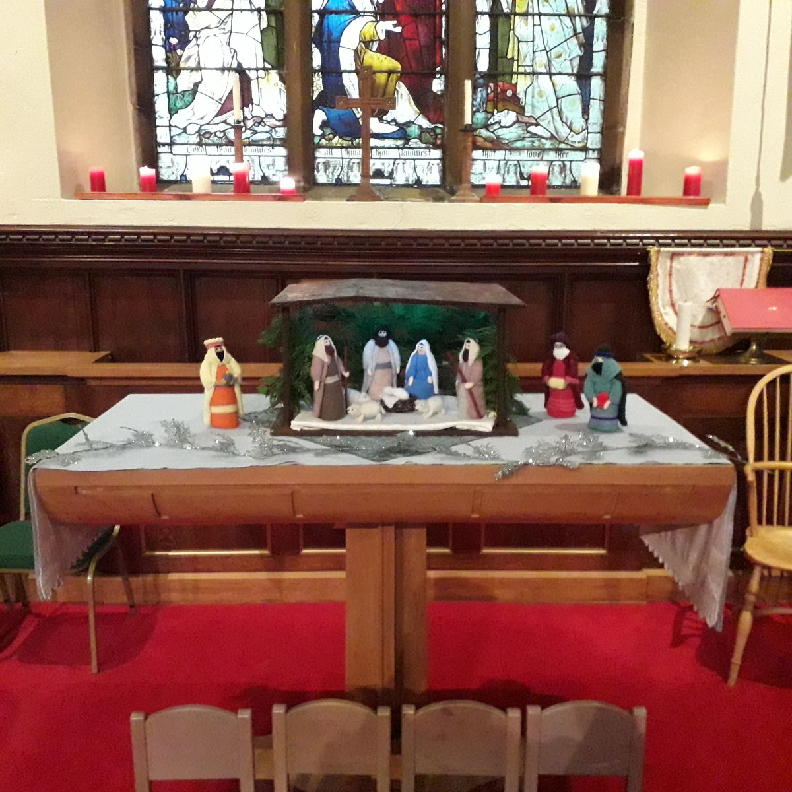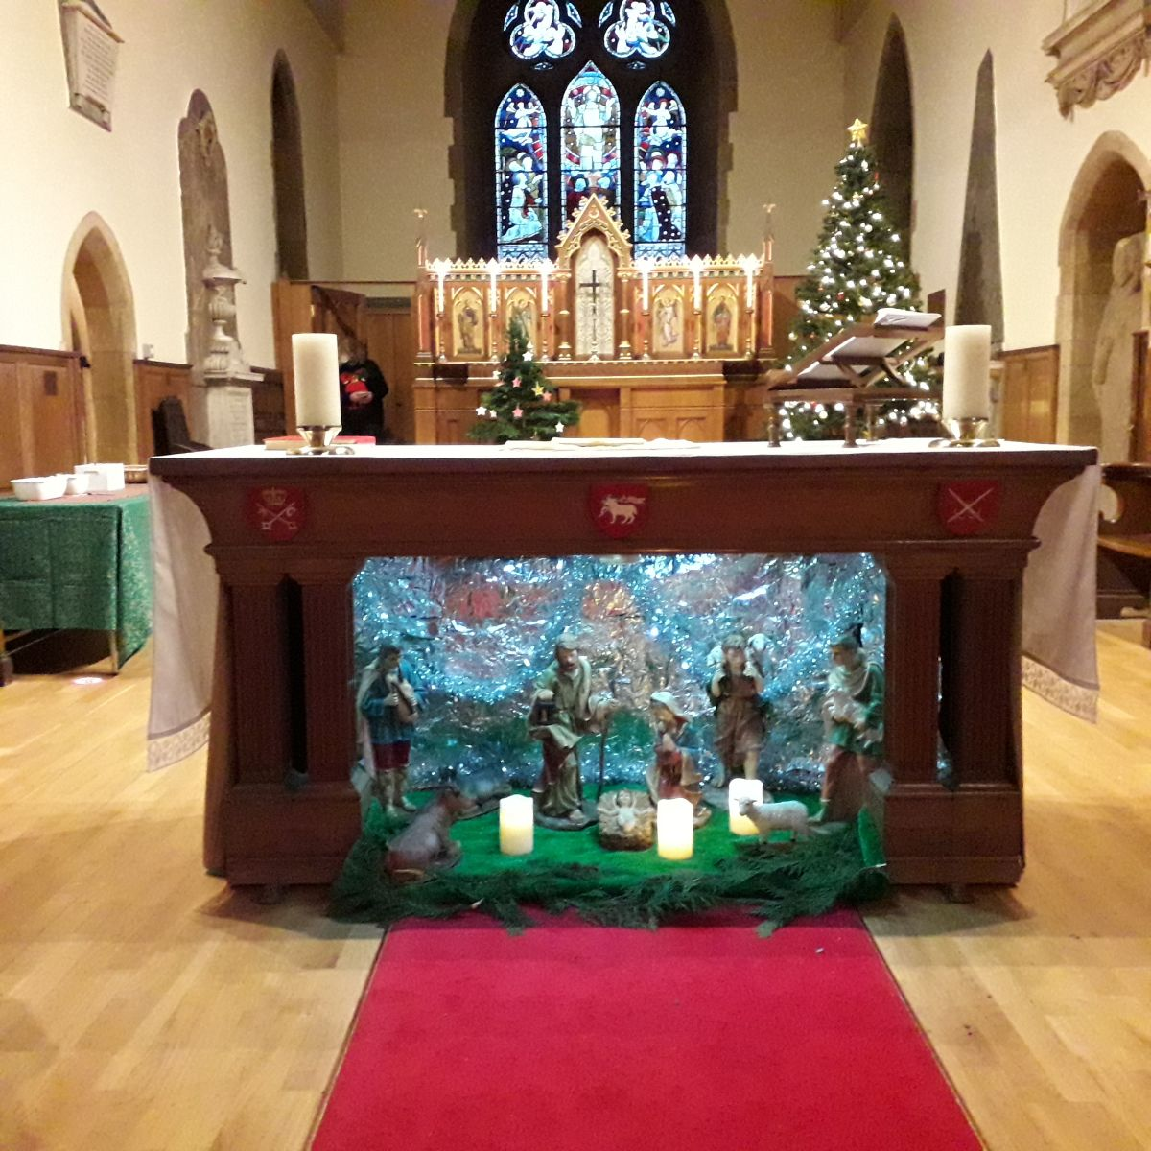

The Coffee and Kids Crib set up with the "Knitivity" knitted figures on the altar in the Hemlington Aisle.
The Church's main Crib set up under the altar in the chancel (you can't see the three Magi because they are on their journey, to arrive to celebrate Epiphany).

Due to the current restrictions our usual Crib Service could not take place this Christmas, so it was decided to try a Crib "walk through" from 2.30-4.00pm with Carols outside afterwards.
We had the Coffee & Kids Crib and knitted figures set up on the altar in the Hemlington Aisle, a number of Christmas videos showing on the screen next to the Lectern and the usual Crib under the main Altar in the Chancel; also, by the Reredos, there was a Memory Tree (on which tags with names could be hung) and candles to remember loved ones.
All the children had an activity pack and book to take away.
There was quite a steady flow of children and parents through the afternoon numbering around 65 – 70 in total.
At 4pm there were carols outside in the churchyard with the Bishop of Whitby playing the portable piano in the Church Porch, with a number of people turning up just to sing; due to the driving sleet and snow this was cut short by 10 minutes but it was very moving.
Many thanks, to all who were involved in the preparation and the running of the afternoon.
Hopefully next Christmas we should be back to normal (whatever that might be) but the "walk-through" has given us food for thought of what we can do in the future.

Vernon Clare

An Excerpt from a 4th Century Hymn of St Ephrem,
on the Night of the Nativity (Christmas Eve)

On this day when the Rich One was made poor for our sake,
let the rich man also make the poor man a sharer at his table.
On this day a gift came out to us without our asking for it;
let us then give alms to those who cry out and beg from us.
(As quoted by the Embrace the Middle East charity, formerly known as the Bible Lands Society)

Proposal to re-unite Hemlington and Stainton
The benefice and parish of Hemlington was formed in 1993 from part of the area of the parish of Stainton. The church of St Timothy, Hemlington, the only church in the parish, is subject to severe structural challenges and was the subject of a recent draft pastoral scheme for closure and demolition. The parish has struggled in recent years and the Diocesan Mission and Pastoral Committee's preferred way forward would be for the parish of Hemlington to re-unite with its mother parish of Stainton.
The Church Commissioners have published a Draft Pastoral Scheme which provides for:
- the termination of the plurality established for the benefice of Stainton with Hilton and the benefice of Brookfield;
- the union of the benefice of Hemlington and the benefice of Stainton with Hilton and their constituent parishes of Hemlington; and Stainton, but with the parish of Hilton continuing distinct;
- the transfer of the parsonage house of the benefice of Hemlington to the York Diocesan Board of Finance for diocesan purposes;
- the future patronage arrangements for the new benefice; and
- the new benefice of Stainton with Hemlington and Hilton and the benefice of Brookfield to be held in plurality by one incumbent, for the appointment of the first incumbent and her place of residence to be the parsonage house of the benefice of Brookfield and for the future patronage arrangements of the benefices so held in plurality.
Anyone may make representations for or against all or any part or parts of the draft Scheme (please include the reasons for your views) preferably by email or by post (*) to reach the Church Commissioners no later than midnight on 15 February 2021. Full details of the proposals are available in the following documents.
A letter from the Church Commissioners about the draft Pastoral Scheme at this link and how to submit any comments you may have;
A formal Notice about the proposed Pastoral Scheme at this link (copies of the Notice have been posted on the notice boards in all three Churches in our Plurality);
A copy of the draft Pastoral Scheme at this link; and
A glossary of the terms used in the documents at this link.
(*) e-mail responses should be sent to: james.davidson-brett@churchofengland.org
Postal responses should be sent to:
Mr James Davidson-Brett, Church Commissioners, Church House, Great Smith Street, London SW1P 3AZ

With all good wishes

Bob

Mr R G Ardley,
Ashdale House,
26 Meldyke Lane,
Stainton,
Middlesbrough
TS8 9AU
Tel:01642-284525
mailto:bob.ardley@ntlworld.com

