Greetings to Stainton and Hemlington Church Members and Friends of Stainton Church

Welcome to the Stainton Church e-News for

Friday 29th March 2024

We hope you are well and keeping safe. If you need any
practical support, please do get in touch.



This is a reminder that British Summer Time (BST) begins this weekend so don’t forget to put the clocks forward one hour before you go to bed on Saturday evening (*); hopefully then you will not oversleep and risk missing or being late for the Easter Day services!

(*) Editor’s Note: BST actually begins at 2.00am on Sunday morning.

_____________________________________

Palm Sunday 24th March 2024 - A Red Letter Day for our Parishes!

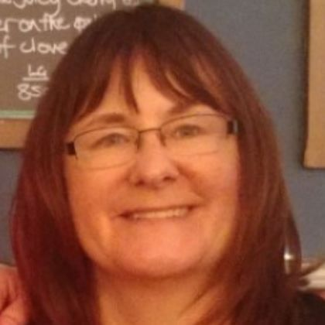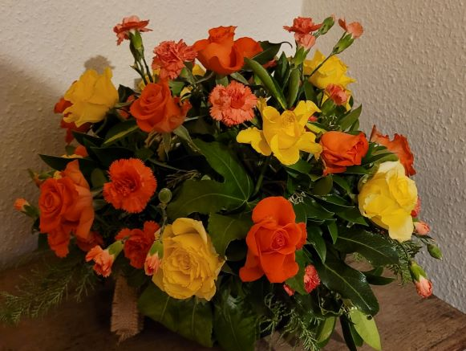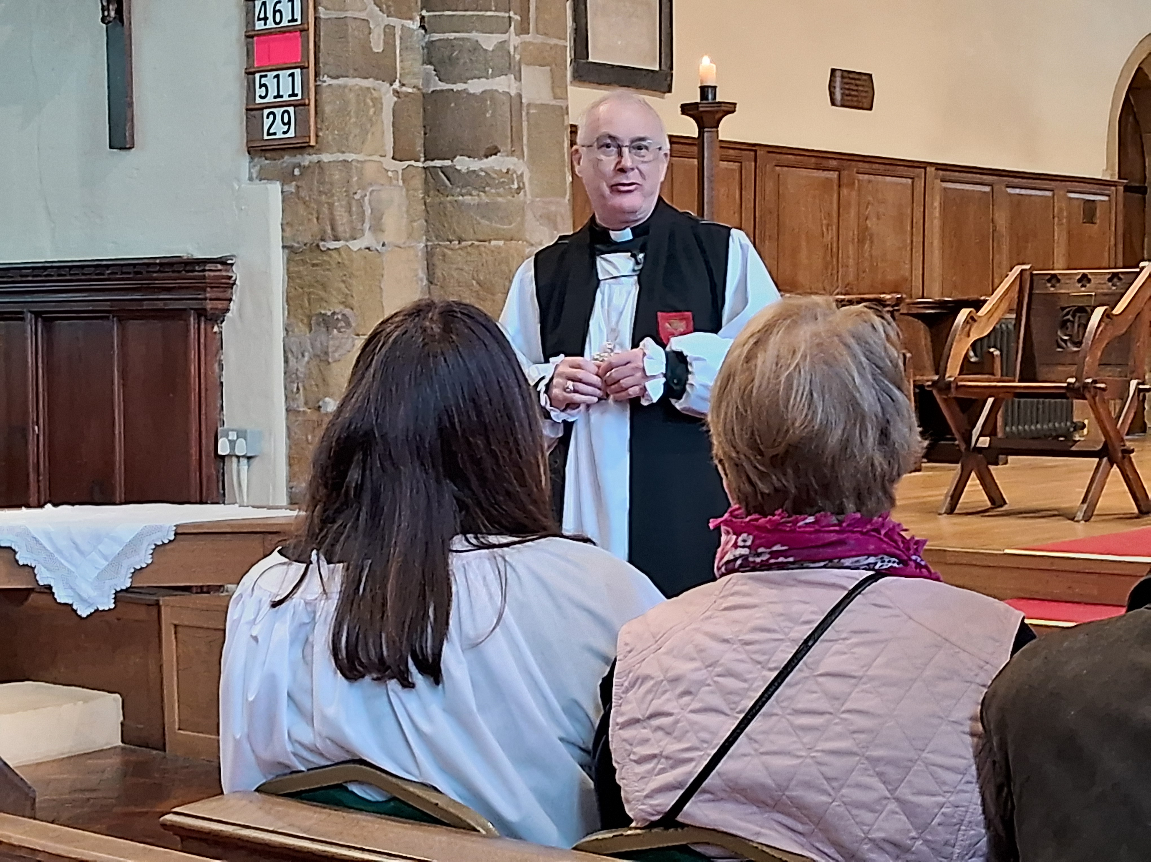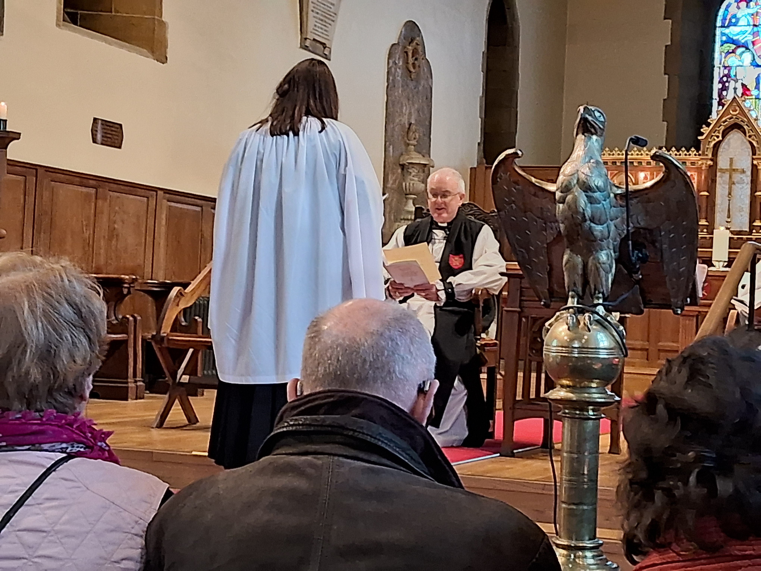

Last Sunday – Palm Sunday – the Revd Vanessa Kirby was Licensed by the Bishop of Whitby, the Rt Revd Paul Ferguson (acting on behalf of the Archbishop of York), as our Pioneer Priest. The photos above show: Bishop Paul addressing the congregation; and reading the formal License document to Vanessa; and the beautiful arrangement of flowers presented to Vanessa during the refreshments served in the Stainton Memorial Hall immediately after the service.

Revd Vanessa would like to express her thanks for all those who gave so much to make her Licensing last Sunday afternoon so special. She writes:

Thank you to everyone who had a part to play in my Licensing Service - for the thoughtful symbolic gifts I was given to mark my ministry as a Pioneer Priest, for the wonderful reception with delicious homemade cakes and for the beautiful flowers I was presented with. There was such a tangible warm welcome throughout the afternoon, which family and friends commented on. I look forward to serving God with you and amongst you that others may know the hope of Christ.

With love and prayers

Vanessa

_____________________________________

Preparing for Easter

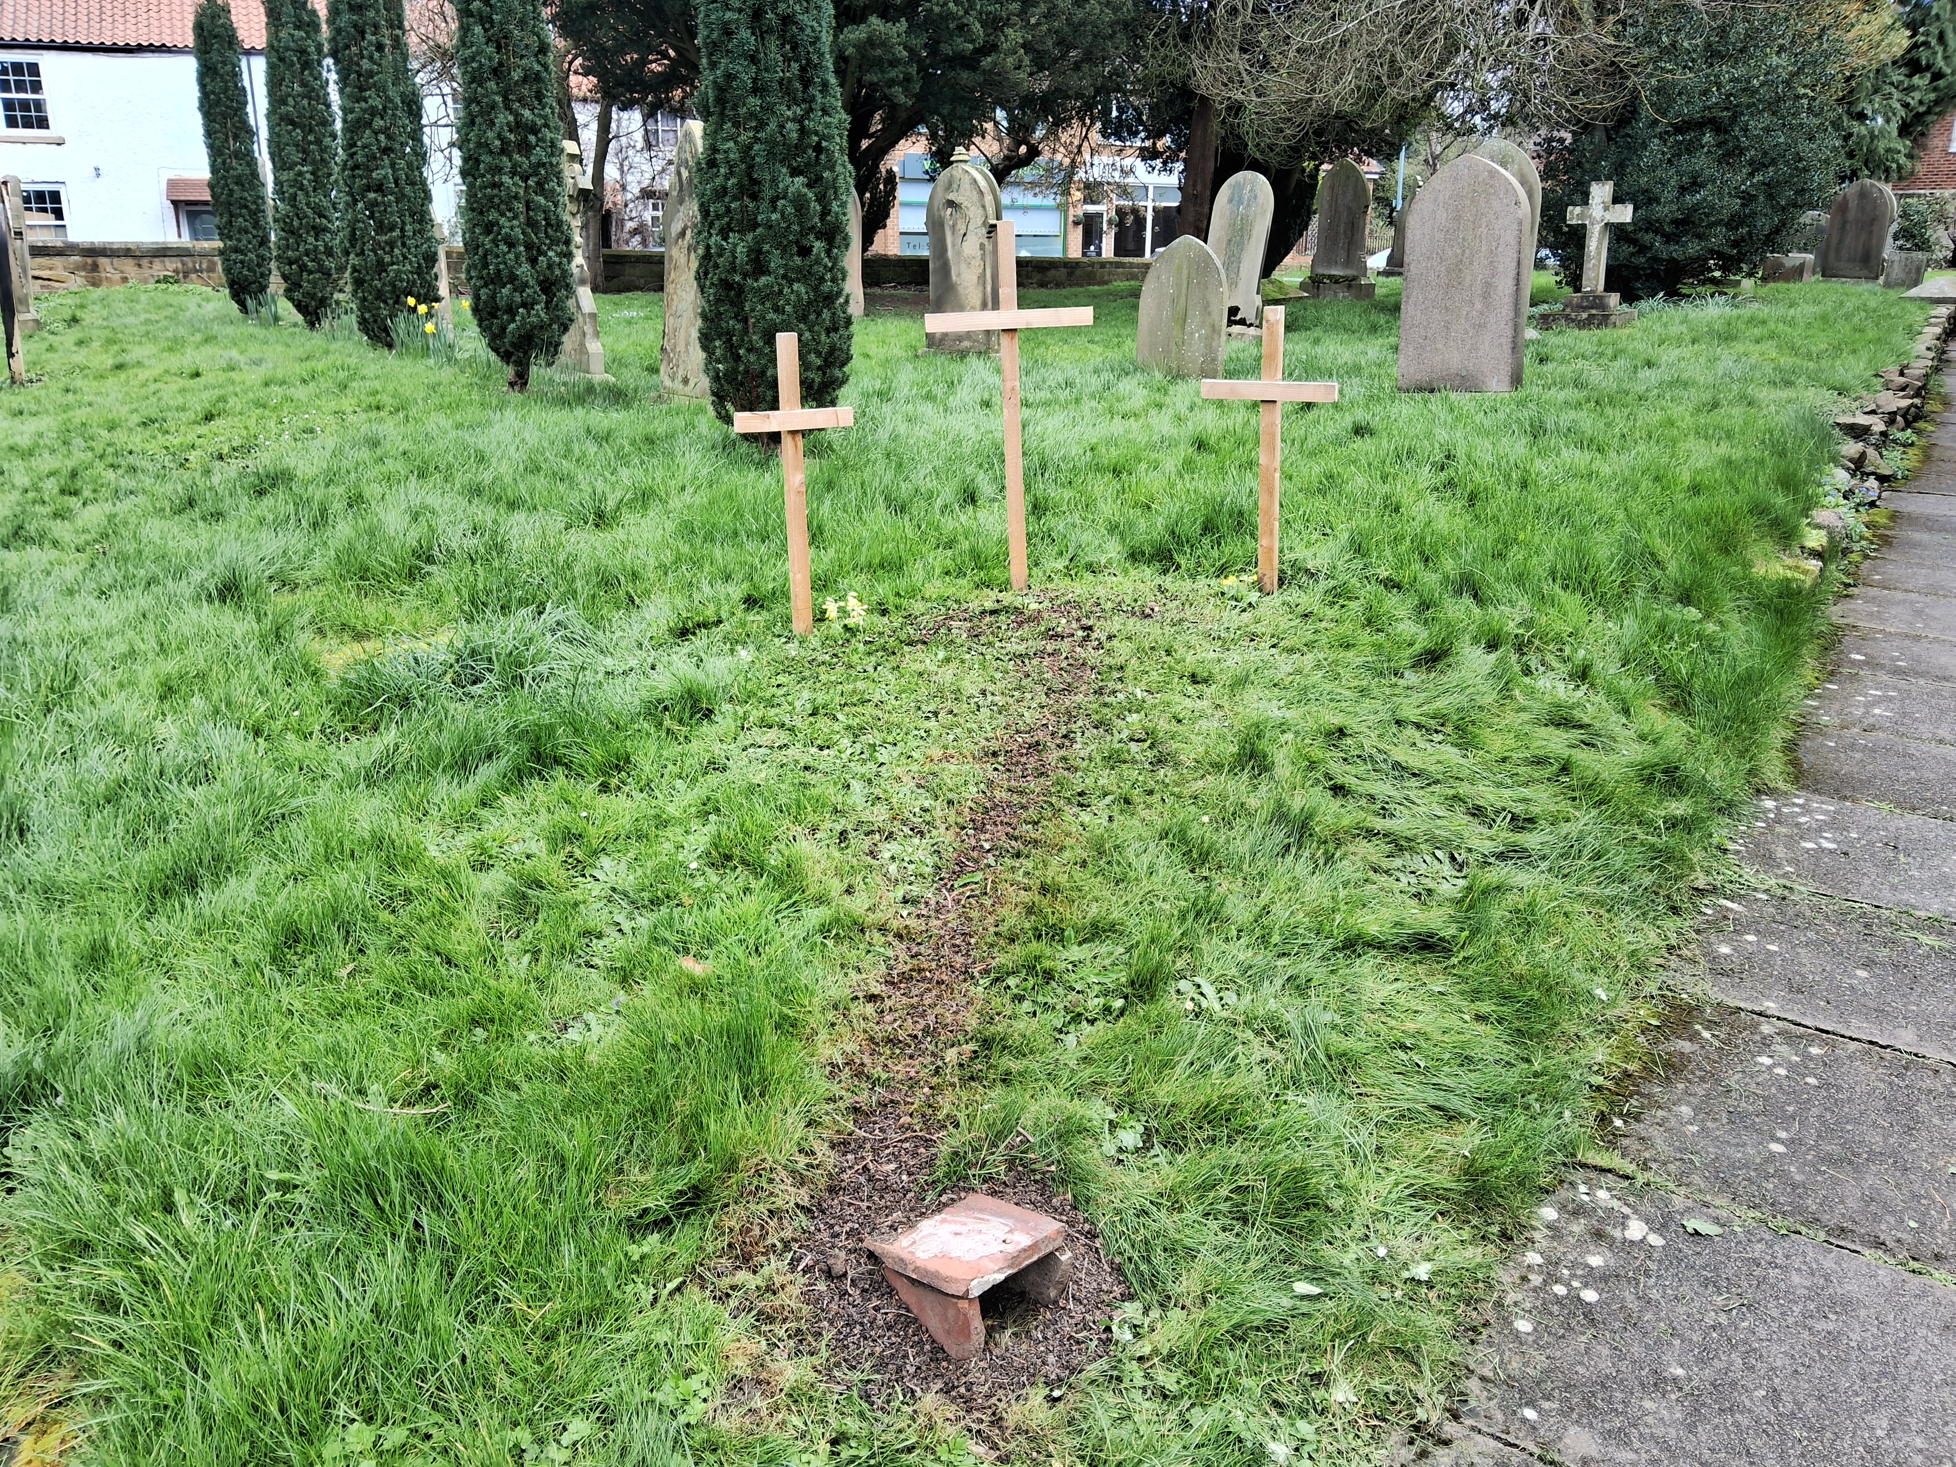

On Holy Saturday 30th March 2024 at 10.00am until 12.00 noon there will be a Family Easter Crafts Session in Stainton Church which is open to children of all ages (0yrs to 99yrs of age). The Coffee and Kids Team will be there with hopefully many of the current C&Ks children and their (grand)parents / carers and perhaps even some of the older children who have moved on to other things having graduated from C&Ks.

You will see from the photo above that Vernon has prepared the Easter Garden in the Churchyard but he needs some help to finish it off. Inside the Church there will be decorating to do and lots of craft activities … there may even be some chocolate Easter eggs to find!

Do come along and join in the fun – there will be lots to do!

_____________________________________

Services and Events in our Churches over the next two weeks

On Sunday 31st March 2024

Easter Day - Alleluia! Christ is risen – He is risen indeed, Alleluia!

There will be services as follows:

At 9.30am at Hilton Church – a Family Holy Communion service for Easter at which our Vicar, Revd Laura Wild, will preside.

At 9.30am at Brookfield Church – a Family Holy Communion service for Easter at which the Revd Marie Edwards, will preside.

At 11.00am at Stainton Church – a Family Holy Communion service for Easter at which our Vicar, Revd Laura Wild, will preside.
The lessons set for Easter Day are:
- Acts 10:34-43
- Psalm 118:1-2,14-24
- 1 Corinthians 15:1-11
- John 20: 1-18
The Diocesan Reflection for Easter Day is given by the Archdeacon of York, the Ven Sam(antha) Rushton. Archdeacon Sam reflects on us all being Easter People. The Reflection can be found at this link.

On Tuesday 2nd April 2024 at 9.30am at Stainton Church there will be a half-hour Prayer Gathering.
On Wednesday 3rd April 2024 at 10.00am at Brookfield Church there will be a service of Holy Communion at which the Vicar, Revd Laura Wild, will preside.
_____________________________________

On Sunday 7th APRIL 2024 – Easter 2 – there will be a single Joint Church Family (Plurality) service of Holy Communion at Brookfield Church and at which our Vicar, Revd Laura Wild will preside.

Note: there will NOT be a service at Stainton Church or at Hilton Church on that day.

The lessons set for Easter 2 are:
- Acts 4:32-35
- Psalm 133
- 1 John 1:1 – 2:2
- John 20:19-end

The Diocesan Reflection for Easter 2 will be available at this link in due course from about the Thursday of the preceding week.
On Tuesday 9th April 2024 at 9.30am at Stainton Church there will be a half-hour Plurality Prayer Gathering.

On Holy Wednesday 10th April 2024 at 10.00am at Brookfield Church there will be a service of Holy Communion at which our Vicar, Revd Laura Wild, will preside.
_____________________________________

Stainton with Hemlington Annual Meetings 2024

The 2024 Annual Meetings for our Parish – the Meeting of Parishioners (MoP) to elect the Churchwardens and the Annual Parochial Church Meeting (APCM) to elect some PCC Members and receive the 2023 Annual Accounts and 2023 Annual Report – will be held in Stainton Church on Sunday 28th April 2024 immediately after the 11.00am service that day. Fuller details are available at this link.

Copies of the meeting papers (Agendas for this year’s meetings and the Minutes of last year’s meetings; the Annual Report for 2023, and the Accounts for 2023) will be sent by e-mail (or hand delivered) to Stainton Church Members on the Electoral Roll on Saturday 6th April 2024.

Important note: Any e-News reader who considers themselves a member of Stainton Church is invited to apply to have their name added to the Church Electoral Roll. The formal revision of the Roll began on Saturday 23rd March and will finish on Saturday 6th April so there is still time to apply to join the Roll. Application forms to join the Roll are available in Stainton Church or can be downloaded from the Annual Meeting page on the website. Completed from should be returned to Bob Ardley, Electoral Roll Officer as soon as possible – the forms can be given to Bob at the Easter Day service or delivered to him at home at 26 Meldyke Lane, Stainton.

_____________________________________

Two Bishops look back on ministry.
The Bishops of Whitby and Selby, Paul Ferguson and Dr John Thomson, were invited by the Archbishop of York at this week's Chrism Service (*) in York Minster to give their own reflections on Christian Ministry as they both approach retirement in July. Here's what they said:
The Bishop of Whitby, the Rt Revd Paul Ferguson:
A long time ago I worked in a church where we had informal Sunday evening services. There was a young woman who often came to them. We both moved on. It so happened that almost 20 years later we found ourselves in contact again. ‘Thanks for the services.’ ‘How are things?’ ‘Fine. It’s been a long time (she said), but I can pray now.’
I can pray now — with four words she taught me so much about ministry. It’s a privilege to be part of someone’s faith journey: but there’s no programme, no timetable. As ministers we can encourage, we can set the scene perhaps, but neither from a divine or human point of view are we in control. And if there’s anything about the ministry that we do that’s effective, we might see the evidence of that, or it might not happen in such a way that we will.
So thank you for being here this morning [at the Chrism Service]: thank you for being people who have said ‘yes’ to the call of Jesus on our lives, perhaps decades ago, not knowing what that might bring, and still ready to say that ‘yes’ new every morning. Thank you for looking beyond the obsessive hanging on instant results. Thank you for your patience when the unavoidable business of managing the organisation nibbles away at the time you would rather spend in prayer, in pastoral care, study or evangelism. Thank you for sticking with the church when it’s how it should be, and when it isn’t.
And thank you for being the people who live out the themes that Paul is wrestling with when he writes to the Corinthians [2 Cor 3.17 – 4.12]: power and vulnerability, death and life: ‘For while we live, we are always being given up to death for Jesus’ sake, so that the life of Jesus may be made visible in our mortal flesh.’ [4.11] In 21st century Britain we may not be called to suffer the persecutions that Paul knew only too well, but there are those who will call us ridiculous or deluded, especially when the gospel compels us to ask radical questions in and of the society in which God has put us, or about its history. For us to carry in the body, and in the body of the church, the death of Jesus [4.10], means that we will live and tell the story of the transforming power of self-giving love ‘so that the life of Jesus may also be made visible’: or, we might say, the people with whom and for whom we minister might glimpse their worth in the sight of God because you love and serve them: the mum who goes without food for the sake of the kids, the bereaved families caught up in the mess in Hull, the exhausted churchwardens, the teachers dreading an inspection, the farmers not knowing whether the numbers will work this year, the person you are praying will explore ministry, the people who trust you with their private joys, hopes, fears, pain and guilt; God’s ‘children [lost] in the wilderness of this world’s temptations’ (do you remember those words from the Ordinal?) and the whole kaleidoscope of people in your congregation, parish, chaplaincy, project, workplace, and those who walk through the doors of this cathedral.
Thank you for being part of a culture shift in the church, through your leadership in fostering and building up God’s gifts in others, and through welcoming experimental ways of mission that sit alongside the time-honoured pattern of sacraments and preaching.
Please remember for your own and your family’s sake that time off is not just a divine gift, it’s a divine command. And if it’s all ever hard going, know that there will be someone who, because of you, can say ‘I know I’m loved; Jesus is real for me; I can pray now.’
The Bishop of Selby, the Rt Revd Dr John Thomson:
I want to begin by telling you two short stories about two couples.
Story 1: A young man from the North-East went to sea aged 15 and eventually became a captain of various ships. During that time he met an old sea captain who gave him a Bible. As a result, he came to faith and felt a call to ordination. Although he and his wife had a young family they sold their home to pay for his training and thereafter all their ministry was in the north of England. I met them when they were serving Christ in a set of mining villages outside Whitehaven in Cumbria.
Story 2: A young woman and a young man independently had come to faith at university and felt a call to go to Uganda in East Africa, the woman to start a school for girls, the man to teach physics in the young university. They met through the African church, got married and had their family there before returning to the UK after 20 years of service to find that there was no equivalent university work for the man, a costly experience.
The first couple were my parents in law. The second couple were my parents.
Both couples showed me that all ministry involves following Jesus through thick and thin without concern for future prospects. They showed me that ministry takes us to the edge of ourselves but that this is the place of growth. They showed me that ministry as loving service tells the Gospel story often better than words. They were exhibitions of the foot washing Christ in John 13, the Christ Hymn in Philippians 2 and today’s Gospel reading from Luke 22 v24-30.
Their stories and my own ministry journey in Sheffield, South Africa, Doncaster and in this Diocese have taught me that:
a. In ministry the way to UP is DOWN.
Ministry means ‘going wherever Christ calls us to go’. This involves relinquishing control and risking the future with God. And what I notice is that Christ primarily goes to those people and communities which others write off. So the way UP to God means going DOWN to where God is most concerned, serving those who have been written off as the Christ Hymn of Philippians 2 shows.

b. In ministry the way to IN is OUT.
Jesus and Paul both discovered God’s call by serving on and from the margins… Jesus spent most of his time in Galilee rather than in Jerusalem and Paul was always looking for the next edge in mission. Ministry has taken me to my edges, culturally, linguistically, educationally and in terms of my own capabilities. Yet such experience has grown my faith and my greatest educators have been the communities where I have felt most out of my depth such as Doncaster and South Africa.
c. In ministry the way to TALK is to WALK.
Unless people see the difference Christ makes in our lives as churches and individuals, it is all noise! It is the witness of lives lived to the script of Jesus’ story which display the Gospel. So ministry involves cultivating Christian communities who can improvise upon the story of Jesus in ways that show locals what the story is about in their own contexts and dialects whether that is Sheffield, Rotherham, Doncaster or Selby English or Xhosa, Zulu or Afrikaans.
d. In ministry the way TO Jesus is WITH his Church.
I have learned that there is no escape from being part of the ratbag, porcupine, fallible and frustrating community of the church, local, global and historic. It is the church which gives us the story, language and practices that might just form us into Christian communities characterised by self-giving, sacrificial, self-effacing love and service as signs of this Gospel story.
Conclusion
So what have I learned about ministry over the years?
a. The way to up is down.
b. The way to in is out.
c. The way to talk is to walk.
d. The way to Jesus is with his church.
I saw this in my parents in law’s ministry. I saw this in my parents’ ministry. And I see this as central to the ministry of Jesus and of Paul.
Amen.
(*) The Chrism Mass is a religious service held in certain Christian denominations, such as Roman Catholicism, Lutheranism, and Anglicanism. It is usually celebrated each year on Maundy Thursday or on another day of Holy Week. During the ceremony, the holy oils used for sacraments and rituals are blessed or consecrated, and the clergy reaffirm their Ordination vows
_______________________________

Please continue to pray …..

….. for Syria and Türkiye (Turkey)

For the people of Türkiye and Syria affected by the earthquakes on 6th February 2023.

… for Israel and Palestine

For an end to the war which is causing so much loss of life and destruction.

…. and for Ukraine

Pray for an early end to the war between Russia and Ukraine.
_______________________________

Please join us in praying for our Churches to Grow

Revitalise (*) is the Diocesan “Growing Health Churches” programme which seeks to help us be a viable flourishing presence into the future.
Can we invite you to use our Revitalise "prayer for growth" in your personal quiet times with God?

Revitalise us Lord,
Enthuse in our congregations the desire for mission. Give
Vision to our planning and
Inspire our thoughts as we seek your will.
Teach us to be more like you, Christ
Abiding in you and
Loving one another.
In growing healthy churches,
Sharing our faith, living Christ’s story
Every day, help us to be faithful disciples and bear much fruit. Amen.
(*) You can read more about Revitalise in the Archbishop’s address to the July 2023 Diocesan Synod meeting at this link.
______________________________________

Pastoral Support - Here are the contact details for our Vicar, Revd Laura Wild:

Address: The Vicarage, 89 Low Lane, Brookfield, Middlesbrough TS5 9EF
Phone: 01642-598621
E-mail: rev.laura.wild@gmail.com

Laura's normal "day off" is Friday - if you need to contact her on that day please leave a message on the answerphone.
______________________________________

With all good wishes to you

Bob Ardley

Ashdale House,
26 Meldyke Lane,
Stainton,
Middlesbrough TS8 9AU

Tel: 01642-284525
E-mail: bob.ardley@ntlworld.com

